

Reviewers Guide

A Guide to Evaluating and Reviewing
Microsoft Visual Studio .NET Beta 2

© 2001 Microsoft Corp. All rights reserved.
This is a preliminary document and may be changed substantially prior to final commercial release of the software described herein.
The information contained in this document represents the current view of Microsoft Corp. on the issues discussed as of the date of publication. Because Microsoft must respond to changing market conditions, it should not be interpreted to be a commitment on the part of Microsoft, and Microsoft cannot guarantee the accuracy of any information presented after the date of publication.
This white paper is for informational purposes only. MICROSOFT MAKES NO WARRANTIES, EXPRESS OR IMPLIED, AS TO THE INFORMATION IN THIS DOCUMENT.
Complying with all applicable copyright laws is the responsibility of the user. Without limiting the rights under copyright, no part of this document may be reproduced, stored in or introduced into a retrieval system, or transmitted in any form or by any means (electronic, mechanical, photocopying, recording or otherwise), or for any purpose, without the express written permission of Microsoft.
Microsoft may have patents, patent applications, trademarks, copyrights or other intellectual property rights covering subject matter in these documents. Except as expressly provided in any written license agreement from Microsoft, the furnishing of this document does not give any license to these patents, trademarks, copyrights or other intellectual property.
Microsoft, Visual Studio, the Visual Studio logo, Windows, IntelliSense, Visual Basic, Visual C++, Visual C#, FrontPage, MSDN, ActiveX, Active Accessibility, Windows NT, JScript, Visio, Visual SourceSafe, BizTalk, Visual InterDev, Visual FoxPro, Win32, the Windows logo and the Internet Explorer logo are either registered trademarks or trademarks of Microsoft Corp. in the United States and/or other countries.
The names of actual companies and products mentioned herein may be the trademarks of their respective owners.
Microsoft Corp. • One Microsoft Way • Redmond, WA 98052-6399 • USA

Review Criteria 6
Contents
Introduction 8
Vision for Visual Studio .NET 8
Design Goals for Visual Studio .NET 8
What’s New in Visual Studio .NET Beta 2? 10
Overview 10
Web Hosting 10
Third-Party Downloads 10
Enterprise Features 11
Simplify the Development of XML Web Services and Applications 12
XML Web Services 13
Visual Studio Makes Creating XML Web Services Easy 13
Invoke an XML Web Service 15
Consume XML Web Services Easily 16
XML Web Services and Platform Interoperability 17
Conclusion 18
Build the Programmable Web 19
Web Forms 19
Creating Web Forms 19
Programming the Mobile Internet 21
Build Broad Reach 21
Mobile Web Forms Controls 21
Mobile Internet Designer 23
Devices Capability Mechanism 24
Advanced Features: Extensibility 25
Conclusion 25
Maximize Developer Productivity 26
Industry-Leading Productivity Tools 27
Visual Studio .NET Productivity Tools 27
Introducing Windows Forms 34
Creating a Windows Forms Application 34
Visual Inheritance 34
Precision Form Design 35
Powerful Graphics 35
Lower Total Cost of Ownership 36
Conclusion 36
Rapid Application Development for the Server 37
Server Explorer and Component Designer 37
Server Resources 39
Setting Up and Deploying Server-Based Applications With Ease 42
Run-Time Tracing for Debugging Applications After They Are Deployed 43
Dynamic Properties Change Functionality After Deployment 43
Conclusion 44
Programmability For Distributed Web Applications 45
Visual Studio for Applications Design-Time and Run-Time Engines 45
Distributed Web Applications Become a Development Platform 46
License Program 46
Summary 47
Innovate in Languages 48
Visual Basic .NET: Productivity and Power 50
Language Innovations 50
Additional Modernized Language Features 53
Upgrading From Visual Basic 6.0 54
Conclusion 56
Visual C++ .NET: Performance and Control 58
Power and Flexibility 58
ATL Server: XML Web Services in Visual C++ .NET 58
Managed Extensions for C++ 61
Attributed Programming 63
Writing Robust Code 65
Pure Performance 65
Better Windows Support 65
New Core ATL Classes 65
Conclusion 66
Visual C# .NET: Modern Component-Oriented Language 67
Types 69
Classes 70
Versioning 74
Attributes 74
Conclusion 75
Enterprise Life-Cycle Support 76
Creating Application Construction Kits 77
Enterprise Templates 77
Enterprise Frameworks 79
Summary 80
Business Rules Based Design 81
Rules Expression 81
Contrast to Entity Relationship 82
Advantages of ORM 83
Database Generation and Round Trip Engineering 83
Summary 83
Visually Modeling Software Architecture 84
An Industry-Standard Approach 84
Application Scenario: A Car Rental Software System 84
Free-Form Modeling 90
Summary 90
Performance, Load and Functional Testing of XML Web Services 91
Creating Tests 91
Browser Record Test 91
Configuring Tests 93
Running Tests 93
Analyzing the Results 94
Automating Tests 95
Summary 95
Deployment in Visual Studio .NET 97
Deployment Solutions 97
Types of Deployment 98
Deploy for Debugging on a Remote Machine 99
Microsoft .NET Framework Installer Classes 99
Windows 2000 Support 100
Summary 101
Simplify Development of XML Web Services and Applications 101
Maximize Developer Productivity 101
Innovate in Languages 101
Enterprise Life-Cycle Support 102
Visual Studio .NET Feature Summary 103
Integrated Development Environment (IDE) 103
XML Web Services 104
Web Forms 104
Programming the Mobile Internet 104
Windows Forms 104
Visual Basic .NET 105
Visual C++ .NET 105
Visual C# .NET 106
Creating Application Construction Kits 106
Industry-Leading Database Tools 106
Visually Modeling Software Architecture 107
Performance, Load and Functional Testing of XML Web Services 107
Deployment 107
Visual Studio .NET Features by Edition 108
Frequently Asked Questions 109
For more information: 115

The Microsoft® Visual Studio® .NET development system belongs, in the broadest sense, in the software development category. The leading edge of this category, according to customers and industry analysts, is the distributed application development segment. The software development category contains all developer tools and products, while the distributed application development segment includes only those tools aimed at server- and client-side application development. Microsoft Corp. believes that the main contenders in this segment include the .NET Framework and Visual Studio .NET, WebSphere and VisualAge, and iPlanet and Forte.
Based on the needs of developers and enterprise organizations, the following is a list of criteria for evaluating Visual Studio .NET:

Review Criteria
- Developer productivity, for the full range of development challenges on the client and server sides, as well as integration of everything in between. The notion of rapid application development (RAD) tools (screen painters, data designers, etc.) has long been accepted as an industry standard for application development. To achieve success in this space, the tool set must provide a RAD experience across the entire distributed application platform — clients, servers, data and the deployment environment.
- A complete model for application integration must be an integral part of the tool set, not an expensive afterthought. Customers today are not looking for one single environment to replace their existing systems. Rather, they require a platform that is ready to easily plug into existing and varied IT landscapes.
- Support for existing developer skills. Customers have discovered the exorbitant cost of finding developers who are skilled in specialized technologies. Prominent industry analysts recommend using existing skills whenever possible and avoiding the high cost and high failure rate of relying on the technical skills in shortest supply.
- A comprehensive solution to provide all of the services needed to produce an enterprise-class solution. These include application services such as an object request broker, transaction-processing monitor, complete scripting engine, feature-rich Web server, world-class messaging support, database connectivity, security, monitoring and management infrastructure. All of these services should be integrated and designed to work together so that developers can spend their time building powerful applications, not cobbling together application services.
- Support for creating and integrating components created in multiple programming languages. In the real world, organizations have investments in a wide variety of languages and personnel skills. Without support that embraces these existing investments, organizations are faced with completely replacing or retraining their people, which is an expensive and unfriendly approach.
- Support for loosely and tightly coupled architectures. To achieve performance, scalability and reliability in distributed applications, components can be tightly coupled for some operations, that is, interdependent in real time. Most modern systems have this capability. However, successful platforms also must have complete support for loosely coupled, message-oriented communication, in which the chain of events supporting a distributed transaction is not broken or blocked by any real-time dependencies. Both architectures must be supported completely and naturally so developers create scalable solutions by default.
- A consistent and unified programming model for applications running within and across Internet firewalls. Related to loosely coupled architectures, this criterion seeks out the solutions that enable organizations to learn, build and support a simple programming model for intranet- and Internet-based applications to reduce training and support costs.
- Adherence to public Internet standards. The most successful communications medium in human history has been the Internet, and its success has come about through a series of collaborative processes for determining common methods of communication. In the age of programmable and interoperable Web software components, standards are the only way to ensure that all players can participate.
- A consistent and unified programming model for broad-reach Web-based clients, as well as rich-client interfaces and emerging smart devices. Customers today are evaluating the full range of client devices, including PCs, browsers, personal digital assistants (PDAs) and cellular telephones. Only by having a programming model that elegantly supports all of today’s user experiences, as well as those that will emerge in the future, and contains a simple model for maintaining consistent business logic across any client architecture, will complex, distributed systems be successful.
- A deployment architecture that enables legacy enterprise abilities, as well as new enterprise agilities. The tool set needs to produce applications that are reliable, easily deployable, interoperable, manageable and secure. At the same time, the tool set must empower organizations with the flexibility necessary to get to market quickly and to stay ahead of competitors.
Development tools that embrace these principles will enable customers to lead in their respective industries; to build, deploy and maintain better applications; and to bring new software and services to market faster and less expensively than competitors. The Microsoft .NET Framework and Visual Studio .NET will satisfy these requirements more completely and effectively than other products available, and will continue to do so into the foreseeable future. Microsoft invites you to examine these new tools carefully, and make your own comparison.
This section presents the key features and benefits of Visual Studio .NET, which is built on top of the .NET Framework. Many of the key benefits in the Visual Studio development system require technologies provided by the .NET Framework so Microsoft recommends that you first read the .NET Framework Beta 2 Reviewer’s Guide to fully understand its role in simplifying distributed application development.

Introduction

Vision for Visual Studio .NET
Microsoft’s vision for Visual Studio .NET is to simplify the development of distributed Extensible Markup Language (XML)-based Web services and applications, which will provide access to information anywhere, any time and on any device. As developers have shifted from building single-tier applications for the Microsoft Windows® operating system to client/server-based applications, Windows and Visual Studio have evolved to support them. Now, as businesses are faced with the challenge of integrating customers, partners and suppliers as well as disparate systems and applications, developers must shift their focus to distributed Web-enabled applications and services. Visual Studio .NET will provide world-class productivity and power for every aspect of those applications.
Today, there are more than 6 million professional developers worldwide, and more than 70 percent of them use a Microsoft tool to build their applications. While the most popular application architecture today is client/server-based, the fastest-growing new architecture is the Web, with a browser front-end and programming logic or database connections on the server. Microsoft has been enabling Internet application development with the previous two releases of Visual Studio, as well as through Active Server Pages (ASPs), a Web development technology that first shipped with Internet Information Server 3.0.
Visual Studio .NET meets the requirements for the next big evolution in application development, dramatically simplifying the development of distributed Web applications and services. Visual Studio .NET takes full advantage of the .NET Framework, which uses public Internet standards to enable integration with new and existing applications running on any platform. The tool for building the next generation of the Web has arrived — development will never be the same.

Design Goals for Visual Studio .NET
When the Visual Studio product team began planning for Visual Studio .NET, a number of key design goals guided them. These design goals are described in detail below.

Simplify Development of XML Web Services and Web Applications
In this next generation of the Internet, where Web sites become programmable XML Web services, developers need to be able to expose any application as an XML Web service and to be able to seamlessly consume any XML Web service within their applications. Visual Studio .NET makes it simple to expose any method as an XML Web service. It also enables seamless integration of external XML Web services within the Visual Studio .NET integrated development environment (IDE). Developers are faced with building many types of applications. Visual Studio .NET will provide the most comprehensive set of tools for developers to build the broadest range of applications. With Visual Studio, developers will be able to use a familiar programming approach for a broad range of user interfaces, including browser and mobile clients.

Maximize Developer Productivity
Developer productivity is one of the most important ingredients for success in development projects. Today’s business drivers demand that applications be delivered in ever-shrinking time frames. Visual Studio .NET will continue to build on Microsoft’s track record of delivering productive tools for professional developers by providing features focused on a unified IDE, with appropriate assistance when needed through dynamic help and enhanced IntelliSense® technology as well as automated routine development tasks.

Innovate in Languages
Most professional developers use more than one language. Visual Studio .NET innovates on the most popular development language in the world, the Visual Basic® development system; provides key enhancements to the powerful Visual C++® development system and introduces a new, modern, component-oriented language the Visual C#™ development system. With Visual Studio .NET, power tools are in the hands of all developers enabling cross-team sharing and reusability.

Enterprise Life-Cycle Support
In most successful projects, developers will spend the majority of development time on tasks other than coding, such as planning, deploying and managing the application as well as collaborating with other team members. Visual Studio .NET targets the entire development life cycle with tools for more than just code development and provides an Open Tools Platform for third-party products to address the needs of development teams.

Overview

What’s New in Visual Studio .NET Beta 2?
Microsoft Visual Studio .NET Beta 2 offers several new features to developers:
- Web hosting
- Third-party downloads
Benefit Summary
- Web Hosting
- Third-Party Downloads
- Enterprise Development Features
- Enterprise features
One of the biggest challenges in creating XML Web services and ASP.NET Web applications on the Internet is the lack of ASP.NET Web hosters, or Internet service providers (ISPs). With the beta 2 version of Visual Studio .NET, several companies are providing hosting of ASP.NET Web applications and XML Web services. Now developers can build .NET applications that run live on the Internet.
Building applications is a process of creating code, reusing code and leveraging third-party add-ins to simplify the process. In the beta 1 version of Visual Studio .NET, finding add-ins was a challenging task — developers had to surf the Web looking for components to use within Visual Studio .NET. With the beta 2 version, these third-party components can now be found easily on the Visual Studio .NET Start Page.
Developers need more than just powerful tools for authoring code. They need tools that simplify all of the other enterprise development tasks required to build scalable applications. Visual Studio .NET Enterprise Developer provides all the tools that developers need to create scalable applications, while Visual Studio .NET Enterprise Architect provides the tools required for corporate architects designing .NET-based applications.

Web Hosting
Developers who want to deploy Visual Studio .NET-based Web applications and XML Web services will be pleasantly surprised by the inclusion of a new tab on the Visual Studio .NET Start Page that lets them choose from a list of ASP.NET Web hoster sites. These sites provide hosting and are integrated with Visual Studio .NET to facilitate the deployment of completed XML Web services and applications through a wizard.

Third-Party Downloads
Hundreds of software component and language vendors, training companies, and other partners have already adopted and created .NET software that is available for developers to use to extend their solutions built with Visual Studio .NET. These third-party resources can be easily found on the What’s New tab on the Visual Studio .NET Start Page.
The What’s New tab provides a place for developers to learn about new and interesting features in Visual Studio .NET, as well as a place to learn about third-party vendors that provide developer tools, .NET languages and controls, and components that work with and integrate into Visual Studio .NET. These partners and products provide essential resources to Visual Studio .NET developers. The combination of Visual Studio .NET and the products provided by these partners create the best development tool set for building the next generation of XML Web services and applications.
From the Online Community tab, developers can access newsgroups and join discussions relating to development issues. The Download tab provides access to additional technologies and samples that can be downloaded.

Enterprise Features
Visual Studio .NET delivers new enterprise life-cycle features to help organizations plan, analyze, design, build, test and coordinate teams to develop XML Web services and applications. These new features will include scalability, performance and functional testing tools for XML Web services; full Unified Modeling Language (UML) 1.2 software modeling; industry-leading database modeling that spans conceptual, logical and physical models; and enterprise frameworks and templates — a set of technologies that will enable software architects to create an application recipe (ingredients and instructions) for developers within the Visual Studio .NET environment.
A new version of Visual Studio .NET, Visual Studio .NET Enterprise Architect, focuses on three key areas:
- Software and database modeling
- Development frameworks and templates
- XML Web services testing
Visual Studio .NET Enterprise Architect edition enables architects to set rules and policies, as well as create guidelines. These can then be implemented using Visual Studio .NET Enterprise Developer.
Simplify the Development of XML Web Services and Applications
By providing fast access to information, the Internet has helped facilitate better communication within and between companies. For many organizations, however, browsing data-driven pages has not proven to be sufficient for their business needs. These companies want to enable a deeper level of systems integration over the Internet. By doing so, they hope to support a number of important application integration and business-to-business scenarios.
Middle-tier business functionality exposed via public Internet standards is known as XML Web services. XML Web services do the following:
- Utilize HTTP as a transport allowing remote method requests to pass through enterprise firewalls
- For security, offer support for the secure sockets layer (SSL) protocol as well as standard Web authentication techniques
- Provide flexibility in regard to component technologies and object calling conventions — as a result, programs written in any language, using any component model and running on any operating system can access XML Web services
In addition, Visual Studio .NET takes advantage of Web Forms, one of the key new technologies in the .NET Framework. With Web Forms, developers will be able to build Web user interfaces simply. Visual Studio .NET addresses the gulf between the techniques used to build desktop applications and those used to create Web applications. With Visual Studio .NET and Web Forms, developers can rapidly develop multiplatform, cross-browser programmable Web applications using the same techniques previously used to build form-based desktop applications.

XML Web services is a core technology provided by the .NET Framework. XML Web services offer incredible value to organizations. Not only can companies more easily integrate internal applications, but they also can access services exposed by other businesses. By combining XML Web services exposed on the Internet with internally built services, companies can create a wide variety of value-added applications. For example, a company could unify banking, electronic bill payment, stock trading and insurance services into a single, seamless financial management portal. Another possibility is the integration of inventory control, fulfillment mechanisms and purchase-order tracking into a comprehensive supply-chain-management system.

XML Web Services
Benefit Summary
- Quickly expose any function as an XML Web service
- Easily incorporate XML Web services from any platform or operating system
The power unlocked by XML Web services represents a generational change in the use of the Internet. Browsing used to be the focal point of the Internet, but now, developers can program the Web to create new business opportunities. As the integration of services occurs, the Web will become the fabric that ties together all computing devices.
Today, this is complicated, but Visual Studio .NET will simplify development of XML Web services by integrating XML throughout the entire tool. Visual Studio .NET will help developers automate the task of building, testing and deploying the complex XML data structures for any component.

Visual Studio Makes Creating XML Web Services Easy
To demonstrate how Visual Studio .NET can assist developers, we will walk through the creation of a simple stock-rating service. For simplicity, the rating service will return “Buy” if the ticker symbol for a recommended stock is entered. Of course, for production systems, there is no limit to the code complexity that can be encompassed by the service.
- We begin by opening Visual Studio and creating a new Visual Basic XML Web service Project called “Stocks.”
- Next, we open the XML Web service in code view and write some code.
- Finally, we type in the attribute <Webmethod()> as part of the function definition.
<WebMethod()> Public Function GetRating(ByVal ticker As String) As String
If ticker = “MSFT” Then
Return “Buy”
Else
Return “Don’t buy”
End If
End Function
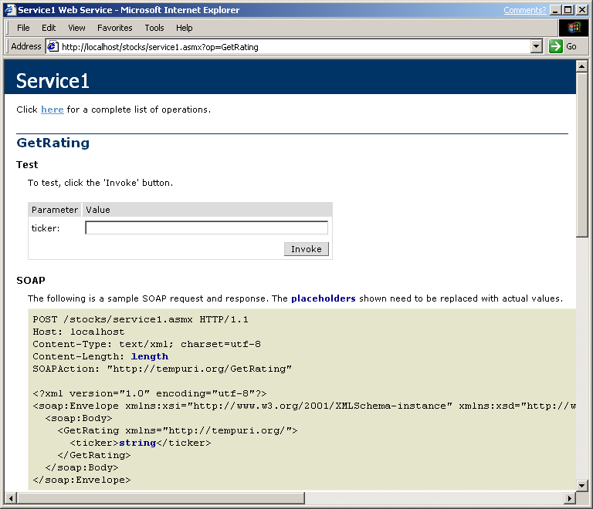
That’s it. When the Build key is pressed, Visual Studio compiles the code and deploys it to the Web server. By adding the <WebMethod()> attribute to the function, the Visual Studio compiler instructs the .NET Framework to expose the method to Web clients. Besides invoking the methods through the XML Web service URL, the .NET Framework also automatically exposes two more features. If a user browses to the URL, the server will return an HTML description page for the XML Web service. This page displays information about the methods available on the XML Web service and also enables users to invoke the methods from the Web browser.

The XML Web service description page is an automatically generated interface to XML Web services.
If users browse to an XML Web service with ‘?WSDL’ at the end of the URL, the server will return an XML document that describes the XML Web service. This document specifies the public functions of the service, the input parameters and data types, as well as the return data types. The important thing to remember is that Visual Studio .NET automatically creates this interface.

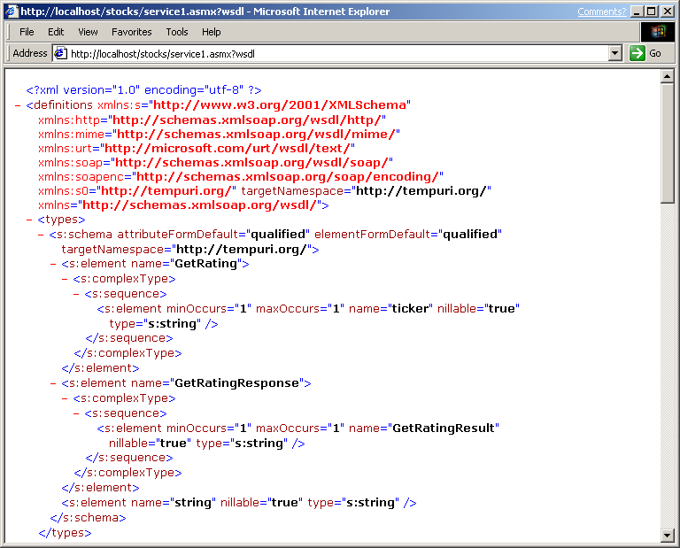

The WSDL document, generated automatically, specifies in XML how to work with the XML Web service.

Invoke an XML Web Service
Once the XML Web service has been built, it can be invoked via HTTP using XML to pass data to and from the service. Developers can test an XML Web service function directly from a browser passing the method name and parameter data through the URL. The .NET Framework will automatically package the result in XML to return from the service.

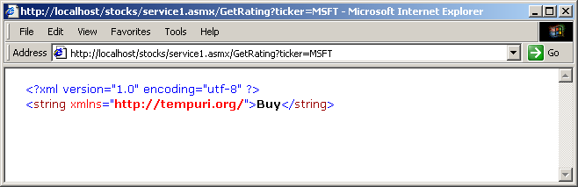
XML Web services return XML results to a browser.

Consume XML Web Services Easily
To use an XML Web service from Visual Studio, all users need to do is add a Web reference to it. The Add Web Reference command launches a dialog box that allows users to locate the XML Web service on the Internet, locally or in the Universal Description, Discovery and Integration (UDDI) registry. After browsing to the XML Web service URL, users will be able to reference the service from their project. Because the Web Services Description Language (WSDL) for the XML Web service contains both the URL of the XML Web service and all the available functions, Visual Studio can automatically create the “plumbing” necessary to call the service from the code.

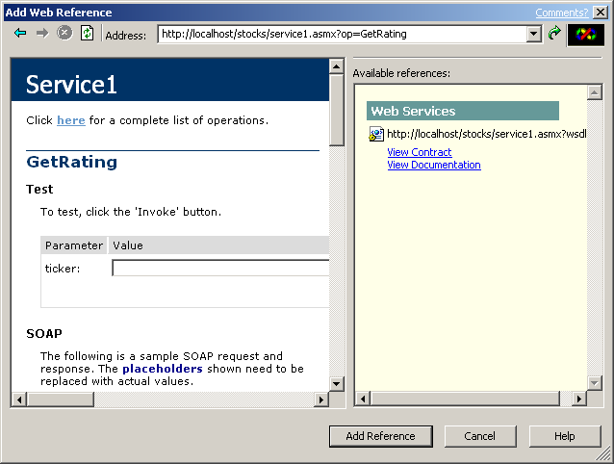

Using the Add Web Reference dialog, developers can browse to a server and easily reference its XML Web service methods.
Once the Web Reference is added to the service, Visual Studio provides full statement completion to access its functions. Calling the XML Web service is as simple as creating a new instance of the XML Web service class and then calling its methods.

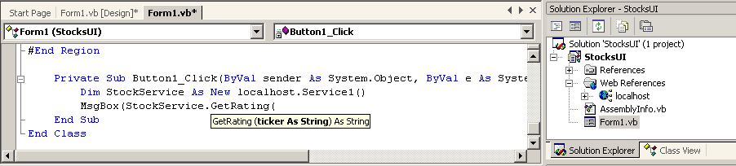
Visual Studio enables statement completion on XML Web services.

XML Web Services and Platform Interoperability
Because XML Web services are accessible using URLs, HTTP and XML, programs running on any platform and in any language can access XML Web services. The XML Web services themselves do not need to be written using Visual Studio or to be running on the Windows operating system. For example, the stock-rating service shown above also could have been created using a UNIX operating system with an Apache Web server. The big advantage to using Microsoft technologies is that it is far easier to create and assemble XML Web services with Visual Studio .NET.

Conclusion
Visual Studio .NET will dramatically reduce the complexity of creating the next generation of distributed Web applications and services. Developers using the Visual Studio development system will be able to develop applications targeting the Web exactly the same way that they build RAD applications today — no new learning. Visual Studio .NET also will significantly reduce the complexity of creating programmable XML Web services. These services will build upon public Internet standards, including HTTP and XML. By making it easy and by supporting industry standards, Microsoft can help developers using Visual Studio create the next-generation Web.

Web Forms

Build the Programmable Web
With Web Forms, Visual Studio .NET addresses the gulf between the techniques used to build desktop applications and those used to create Web applications. With Visual Studio .NET and Web Forms, developers can rapidly develop cross-browser Web applications using the same techniques previously used to build form-based desktop applications.
Benefit Summary
- Build highly scalable Web applications with Web Forms
- Leverage existing skills using a familiar development paradigm
- Visually lay out Web pages with the shared Web Form Designer
- Build broad-reach applications that target any browser
- Share application logic across Windows-based clients, browsers and mobile devices
- Simplify development with business logic separated from the user interface
The core technologies for Web Forms are provided by the .NET Framework, but let’s do a quick review before talking about how Visual Studio .NET makes using them even easier. A standard Web Forms page consists of a Web Forms “markup” file containing the visual, XML-based representation of the page (HTML, WML, XML, etc.) and a source file with event-handling code. The source is compiled into executable code providing fast run-time performance. Both files reside and execute on the server where they generate a Web page that’s sent to the client. The page can be generated as pure HTML 3.2, which means it can be viewed on any platform, with any browser, or it can target the special capabilities of a specific browser. For specifically targeting handheld, Web-enabled wireless devices, Visual Studio .NET has fully integrated the Mobile Internet Toolkit, which will be discussed in the next section.
In Visual Studio .NET, all programming languages share the same Web technologies. Regardless of whether developers choose Visual Basic .NET or Visual C# .NET, the development tools and model are the same. Therefore, users can choose their favorite language in which to build Web Forms.

Creating Web Forms
Web Forms programming is modeled after the way developers have traditionally used Visual Basic to write applications for Windows. For example, constructing a Windows-based form today in Visual Basic 6.0 requires adding a form to the project, dragging controls onto the form and then double-clicking on the controls to write code behind the form. This well-known model is used by millions of developers to rapidly construct desktop applications. Web Forms will bring the same design principles and level of productivity to the Web.

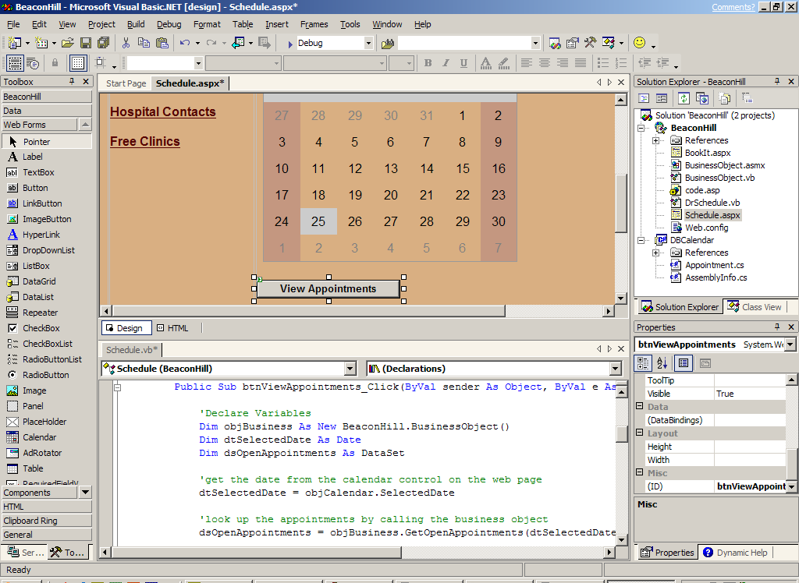

Shared Web Form Designer
From a design perspective, Web forms do the following:
- Use a programming model that is instantly familiar to most developers. Developers can move easily between desktop and Web projects without the need for extensive retraining.
- Separate the HTML layout from the code behind the page. This separation makes it easier to update either piece independent of the other, simplifies code navigation (a problem in big HTML files with embedded script), and enables code to be versioned more easily.
- Offer programming flexibility. Web Forms can be created with any language that supports the .NET Framework, including Visual Basic .NET and Visual C# .NET. HTML pages also can be imported from tools such as the FrontPage® Web site creation and management tool and converted into Web Forms.
Web Forms also have the following run-time advantages:
- Delivery of a programming model and execution framework that enables developers to implement server-generated HTML pages
- Greatly enhanced run-time performance because the code behind the HTML page is compiled into an executable rather than script
- Generation of Web pages that are pure HTML 3.2, which means pages can be viewed on any platform, with any browser
Over the past few years, the world has seen an explosion of new devices, such as cellular phones, pagers and PDAs, which enable users to browse Web sites at any time from any location. Developing applications for these devices is challenging for the following reasons:

Programming the Mobile Internet
Benefit Summary
- Save time by writing user interface (UI) code once for multiple mobile devices
- Take advantage of the features of specific devices
- Leverage existing skills
- Support a broad range of devices
- Different markup languages are necessary, including HTML for PDAs, WML for Wireless Application Protocol (WAP) cell phones and cHTML for Japanese I-Mode phones.
- Devices have different form factors. For example, devices have varying numbers of display lines, horizontal or vertical screen orientation, and color or black and white displays.
- Devices have different network connectivity, ranging from 9.6KB cellular connections to 11MB wireless LANs.
- Devices have different capabilities. Some devices can display images, some can make a phone call, and some can receive notification messages.

Build Broad Reach
The Microsoft Mobile Internet Toolkit addresses these challenges for developers by insulating them from the details of wireless technology. Thus, developers can quickly and easily build a single mobile Web application that delivers appropriate markup for a wide variety of mobile devices.
The Mobile Internet Toolkit contains the following:
- Mobile Web Forms controls that generate a markup language for different devices
- Mobile Internet Designer that works with the Visual Studio .NET IDE to provide a drag-and-drop mobile development environment.
- Rich browser capabilities that extend ASP.NET device capabilities to mobile devices
- QuickStart tutorial with sample code
- Developer documentation
- Device adapter code samples
The Mobile Internet Toolkit generates markup for a wide variety of devices including WAP cell phones, cHTML cell phones, Pocket PCs, Palm devices and RIM Blackberry pagers.

Mobile Web Forms Controls
The mobile Web Forms controls are ASP.NET server-side controls that provide user interface elements such as list, command, call and calendar. At execution time, the mobile controls generate the correct markup for the device that makes the request. As a result, developers can write a mobile application once for multiple devices.
Because these mobile controls are based on the ASP.NET controls, developers can leverage their current desktop development skill set when creating mobile applications. Developers also can reuse the same business logic and data access as in their desktop applications. In fact, mobile and desktop Web Forms can reside in the same Visual Studio .NET project. This makes an application faster to develop and lowers the maintenance cost.
The following example provides just a taste of programming with mobile controls. In this example, the “Hello, World” program creates a mobile Web Forms page with a single form on it; that form contains a label control with the string: “Hello, Mobile World”.

<%@ Page language=“c#” Inherits=“System.Web.UI.MobileControls.MobilePage” %>
<%@ Register TagPrefix=“Mobile” Namespace=“System.Web.UI.MobileControls” Assembly=“System.Web.Mobile”%>

<mobile:Form id=Form1 runat=“server”>
<mobile:Label id=Test Runat=“Server”>Hello, Mobile World</mobile:Label>
</mobile:Form>
The following illustrations show how this code renders on different devices. The first device is a cell phone running a WAP browser that supports WML. The second device is Pocket PC running an HTML browser.

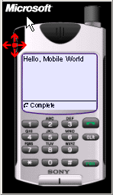
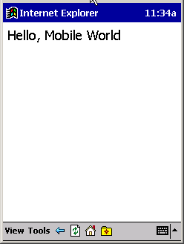

The “Hello, World” program renders to both a cell phone and a Pocket PC.
The Mobile Internet Toolkit also enables developers to customize the markup that is generated by mobile controls for a specific device. Users can designate templates and styles for a specific device within the mobile page.

Mobile Internet Designer
The Mobile Internet Designer extends the Visual Studio .NET IDE for creating mobile applications. After users install the Mobile Internet Designer, they can create and develop their mobile application in the same way that they would develop a Windows-based Forms or Web Forms application. The Mobile Internet Designer leverages the traditional Visual Studio design environment so that users can do the following:
- Create a mobile Web project
- Add a mobile Web Forms page to the project
- Drag a mobile Web Forms control onto the form
- Double-click the control to write the logic
- Rebuild the application
- Run the application
The Mobile Internet Designer makes it fast and easy to build and maintain mobile Web applications. In addition, it enables today’s desktop developers to quickly learn to create mobile applications by using Visual Studio .NET
The following illustration shows a mobile application developed in Visual Studio .NET with the Mobile Internet Designer.

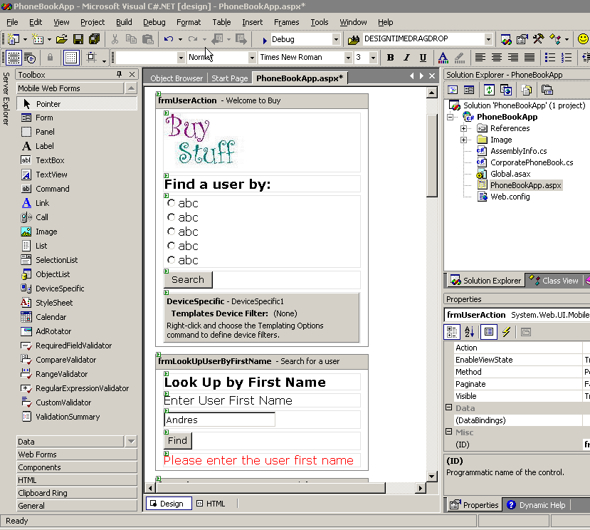

Devices Capability Mechanism
Accurate information about the display capabilities of the target device is essential for successful rendering of mobile controls. At a minimum, the mobile controls need to use the following information about a device:
- Markup language (HTML, WML, cHTML)
- Browser
- Number of display lines
- Cookie support
- Screen size
The Mobile Internet Toolkit extends the schema of the machine.config file, which is used by desktop ASP.NET applications to track device and browser information to include additional characteristics of mobile devices. In addition to extending the schema, the Mobile Internet Toolkit includes device adapters for a variety of mobile devices. The information in this file about device capabilities allows device adapters to optimize markup for specific devices. Device adapters also make the device capability mechanism extensible by third parties.

Advanced Features: Extensibility
The Mobile Internet Toolkit enables developers to create new aggregate controls from existing mobile controls. It also supports device adapters for additional devices through the device capabilities mechanism.

Conclusion
The Mobile Internet Toolkit provides the technology and tools to quickly build, deploy, and maintain sophisticated mobile applications. Tight integration with Visual Studio .NET ensures that developers can leverage their existing skill set and produce mobile applications. Using a pluggable architecture ensures the widest variety of devices supported with minimal developer effort.
Maximize Developer Productivity
Historically, Microsoft has been known for providing the most productive tools for developers. With Visual Studio .NET, Microsoft builds on this legacy, delivering the ultimate developer cockpit that will dramatically increase developer productivity. This single shared IDE enables all developers to work with one tool to build any type of application.
Microsoft is introducing a new shared designer for building Windows-based applications called Windows Forms. It is a new forms technology that enables developers building Windows-based applications to take advantage of the rich user interface features available in the Microsoft Windows operating system. All of the RAD tools that developers have come to expect from Microsoft are found in this version including drag-and-drop creation of Windows-based applications that can fully leverage XML Web services.
Some of the most significant innovations in RAD development in Visual Studio .NET are the new RAD for the Server features, which enable developers to lay out their middle-tier business logic and XML Web services by dragging and dropping server-based resources from the Toolbox and the new Server Explorer window. This provides visual representations of nonvisual objects. Developers can now easily assemble applications with performance counters, event logs and message queues through drag-and-drop techniques. As a result, functions that used to require hundreds of lines of code now require just a handful.
How can an ISV deliver a Web-based application that is fine-tuned to the individual needs of all of its customers? The answer is Microsoft Visual Studio for Applications (VSA). VSA provides a fully integrated way for customers to seamlessly customize and extend the functionality of Web-based applications using familiar tools.

Visual Studio .NET Productivity Tools

Industry-Leading Productivity Tools
Today’s dynamic business environment demands that applications be delivered quickly, maintained easily and upgraded frequently. In this setting, maximizing developer productivity is a crucial component of success.
Benefit Summary
- Maximize productivity using the enhanced, shared IDE
- Quickly find needed information with Dynamic Help
- Customize and track work items with the Task List
- Access and manipulate server resources with the Server Explorer
- Automate repetitive tasks and integrate with other tools using Visual Studio macros
- Save time with the integrated end-to-end debugger
- Instantly access developer resources from the customizable Start Page
Visual Studio .NET addresses these needs by providing a host of productivity tools and enhancements that dramatically simplify the creation of applications for the Web as well as for Windows. Familiar development models such as drag-and-drop form creation combine with an extensive set of new features such as the fully integrated development environment, dynamic help and rich extensibility model to empower organizations with the ability to minimize time to market and stay ahead of the competition. In addition, consistent and unified programming models for broad-reach Web-based clients, rich-client interfaces and emerging smart devices enable developers to use a single paradigm for application design.
By simplifying the development, debugging and deployment of enterprise-critical applications, the productivity tools of Visual Studio .NET help maximize developer resources.

New Shared Integrated Development Environment
Visual Studio .NET provides a new unified IDE for all the programming languages within it. It was designed to help developers build their solutions faster with less clutter and with all of the tools easily accessible in any of the languages used with Visual Studio. In addition, the unified IDE greatly simplifies a task that many development shops face today: management and delivery of multilanguage solutions. It combines the best elements of the IDEs from individual tools (Visual Basic, Visual C++, etc) with new integrated features such as the end-to-end debugger to provide developers with a consistent, fully customizable development environment.

New Visual Studio Start Page
Each time a developer launches Visual Studio, the Start Page is displayed as the default Web browser home page for the IDE. It provides a central location for setting preferred options, reading product news, accessing discussions with fellow developers and accessing other information to get up and running within the Visual Studio .NET environment.
In addition to providing instant access to articles, events and help topics from the MSDN® Online developer program, the Start Page allows developers to access recent, existing and new projects with the click of a button. The Start Page also enables developers to quickly customize the IDE to better suit their development experience. This allows developers using Visual Basic and Visual C++ to instantly set the Visual Studio .NET keyboard mapping scheme, window layout and help topics to those already familiar to them.

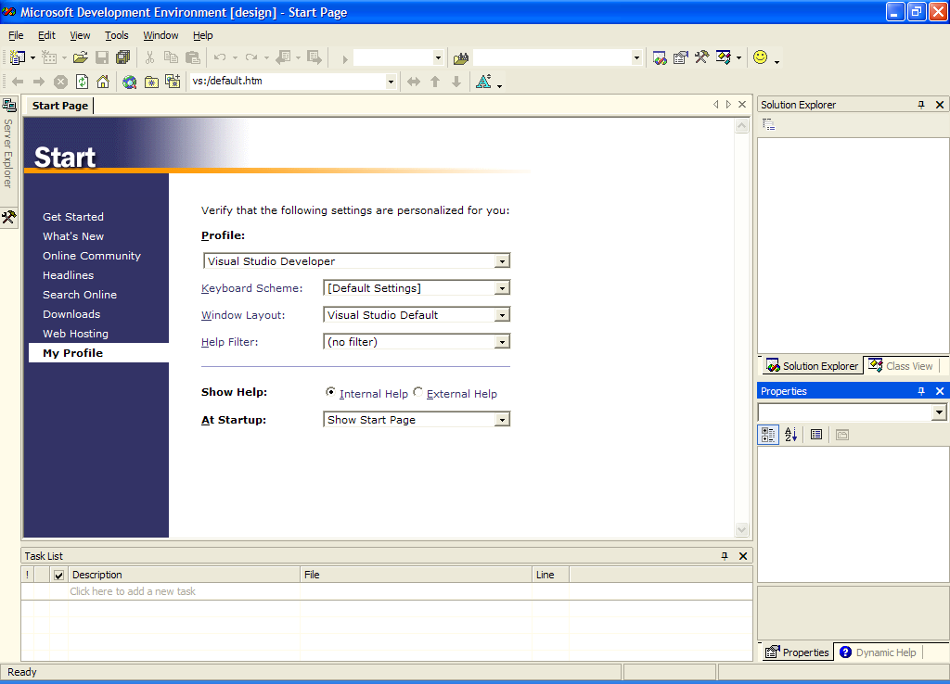
The Visual Studio Start Page is a powerful portal for developer information.

Enhanced Solution Explorer
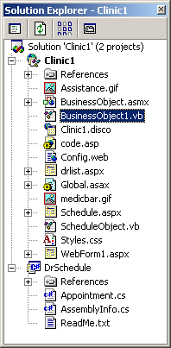
In Visual Studio .NET, the concept of a Project Explorer has been extended to an enhanced, multilanguage Solution Explorer. The Solution Explorer displays an organized list of the projects as well as their corresponding files and directories that make up the current solution. It provides real-time information about items in the open solution and allows developers to manage those items. For example, developers can monitor the current status of source-controlled files, drag and drop items from one project to another, and display solution, project or file properties.

Enhanced Toolbox
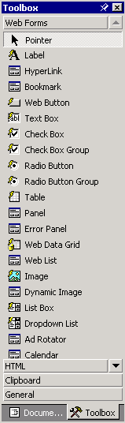Visual Studio 6.0 developers will be immediately familiar with the Visual Studio .NET Toolbox. This enhanced Toolbox window displays a variety of items for use in Visual Studio .NET projects, including Web Form and Windows Form controls, ActiveX® controls, XML Web services, HTML elements, objects and text files. The items available from this window change depending up which designer or editor the developer is currently using.
In addition to offering new components for Web Forms, Windows Forms and data development, code snippets can now be highlighted in the Code Window and dragged onto the Toolbox for later reuse.
Solution Explorer displays the hierarchy of all projects and their corresponding files in a given solution.

The Toolbox lets developers host their components, and even lets developers share and reuse commonly used code snippets.

New Server Explorer
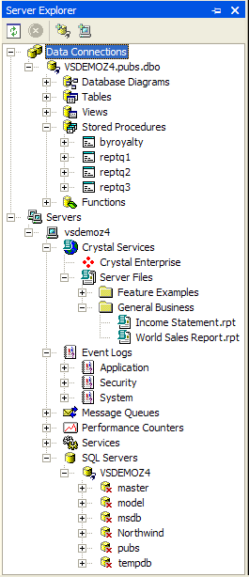
Server Explorer is a new server-development console for Visual Studio .NET. It is a shared tool window that helps developers access and manipulate resources from any machine on which they have appropriate permissions. With Server Explorer, developers can connect to servers and view their server-based resources, including message queues, performance counters, services, processes, event logs and database objects.
In addition, Server Explorer enables developers to programmatically reference these server components and resources within their Visual Studio .NET-based applications, either by adding a component to their project that references the resource or by creating components that monitor the resource’s activity. This includes making data connections to SQL Server™ or other databases; configuring and integrating Exchange 2000 Servers into an application; monitoring processes, services, and DLLs loaded on a server; and debugging server events.

New Task List
In addition to writing code and creating components that make up an application, developers need to be able to annotate their code so that when they, or other team members, open it later in the development cycle, the exact state of the code can be determined without delay. The Visual Studio .NET shared Task List provides this crucial capability to developers by allowing them to mark their code with specialized comments. These comments are then parsed and displayed in a tabular format within the Task List. In addition to the default TODO statement, developers also can customize which “tags” the Task List parses.
The new Server Explorer helps developers access XML Web serviceXML Web services, databases, message queues, and server event logs

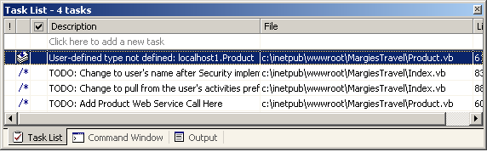
In addition, the Task List serves as a central location where developers can ascertain the status of compile/build errors and warnings. With the Task List window, developers can identify and locate problems that are detected automatically as they edit and compile code. Double-clicking the task jumps the developer directly to the section of code containing the comment. Checking off the task removes the comment altogether. Developers also can filter the task items they view so they only see the items that interest them.

The new Task List lets developers annotate their code so that they can keep track of areas that need attention.

New Dynamic Help
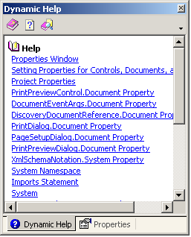
The Dynamic Help window provides one-click access to pertinent help, regardless of the task a developer is attempting to complete. By tracking the selections a developer makes, the placement of the cursor, and the items in focus within the IDE, Dynamic Help filters through topics available on MSDN and provides pointers to relevant information specific to the current development task at hand.
The Dynamic Help window separates the information it displays into several categories, including Help, Actions, Miscellaneous and Samples. Links within these categories are displayed according to their weighted relevance. Developers have a choice of displaying the selected help information within the IDE (by default) or within a standalone view of MSDN.

Enhanced Integrated Debugger
Visual Studio .NET contains an enhanced integrated debugger that shortens the development cycle by giving developers an easy way to run, track and fix errors in their code. The new unified interface combines the best features of the Visual C++ and Visual Basic debuggers with an array of new features. Using the enhanced debugger, developers can track the most complex multithreaded applications.
Developers also can set conditional breakpoints that offer the fastest way to track down programming errors by stopping application execution only when a specified condition is met. Visual Studio .NET offers conditional breakpoint options such as hit counts and per-thread tracking. Also, these breakpoints can be saved as part of a solution in Visual Studio .NET.
With more solutions consisting of cross-language projects, the Visual Studio .NET debugger supports debugging of applications written in multiple languages. With cross-language debugging developers can step seamlessly between Visual Basic, Visual C++, Visual C#, HTML and script. Cross-language call stacks make it easy to debug components written in multiple languages.

New Web Forms Designer
Today’s developers need an intuitive way to create Web pages. Visual Studio .NET includes the shared Visual Studio Web Forms Designer, a graphical way to develop HTML pages and ASP.NET Web Forms without delving into HTML or script code.
Objects in the Web Forms Designer are hosted live on the form in Design mode. Developers can build Web pages and see how they will look when completed at the same time. With the Web Forms Designer, what you see is truly what you get.
Developers also can easily add HTML elements to Web pages by dragging and dropping from the HTML toolbox to create visually complex Web pages without having to write even one line of code. Developers get the benefit of visual layout without the hassle of having to remember HTML code.

New Windows Forms Designer
Windows Forms is the new platform for Microsoft Windows-based application development, based on the .NET Framework. It provides a concise, object-oriented, extensible set of classes that enables developers to quickly develop rich Windows-based applications.
Using the Windows Forms Designer, developers can rapidly develop solutions for use in Windows-based applications. By adding a new Windows Form to a project, the developer can quickly create rich, intuitive user interfaces. After adding a Windows Form to a project, the developer can set form properties, add controls from the Toolbox and write code behind the form.
In addition, the Windows Forms Designer offers new features to enable developers to deploy rich solutions more quickly. For example, developers can use the Anchor property of controls within a Windows Form to automatically ensure that the distance between the control and the specified edge remains constant when the form or container is resized. This alleviates the time — and hassle — that developers previously spent writing code to resize and reposition controls.

New Component Designer
In the same way that form designers enable rapid creation of client applications, the Component Designer helps developers build server-side components quickly and graphically. The Component Designer applies the concepts of RAD forms-based programming to building middle-tier objects — a visual way to build nonvisual objects. Instead of writing lots of server-based code, developers now can drag and drop server components to a design surface that will run on the server. Double-clicking a server component on the Component Designer opens the code for that object.

New XML Designer
The XML Designer provides intuitive tools for working with XML and XML Schema Definition (XSD) files. Within the designer, there are three views: one for creating and editing XSD schemas, one for structured editing of XML data files, and one for editing XML source code.
The schema view provides a visual design surface on which developers can visually construct and edit XML schema. New schemata can be created in the designer by adding new elements, types and attributes to the editor or by dragging tables onto the design surface from Server Explorer. In addition, the schema view enables developers to create relationships between tables and generate ADO.NET datasets.
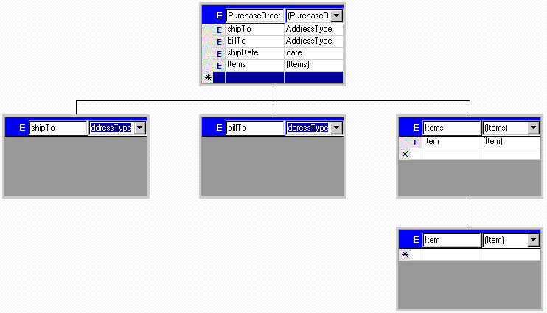
XML Designer allows developers to graphically design XML schema.
The data view is available when an XML data file is added to a Visual Studio .NET project. Using the data view, developers can generate, reference and view a schema associated with an XML file. Developers also can view and edit data using the data view, making it simple to work directly with XML-based data as if it were in a database.
The XML source view provides an editor for creating and editing XML. This view offers developers IntelliSense technology and statement completion for XML files that are associated with a specified schema.

New Visual Studio Macros
Visual Studio .NET comes equipped with a rich extensibility model for customizing, automating and extending the integrated development environment. To best leverage this extensibility model from within the IDE, Visual Studio .NET provides the Visual Studio Macros environment.
This environment, built on Visual Studio technology, allows developers to rapidly customize the behavior of Visual Studio .NET to fit their individual needs. Using Visual Studio Macros, developers can record macros that can later be played back to automate processes within the IDE.

Conclusion
Visual Studio .NET provides a single shared development environment that helps developers build their solutions faster and with access to key productivity features regardless of the programming language used. It combines a consistent RAD paradigm for application design, intuitive tools for server-based development, and a new unified IDE to speed and simplify the design, development, debugging and deployment of XML Web services and applications.

Windows Forms is a new forms package that enables developers building Windows-based applications to take full advantage of the rich user interface features available in the Microsoft Windows operating system. Windows Forms is part of the new .NET Framework and takes advantage of many new technologies including a common application framework, managed execution environment, integrated security and object-oriented design principles. In addition, Windows Forms allows users to quickly and easily connect to XML Web services and build rich, data-aware applications based on the ADO.NET data model. With the new shared development environment in Visual Studio, developers will be able to create Windows Forms applications using any of the languages supporting the .NET Framework, including Visual Basic .NET and Visual C# .NET.

Introducing Windows Forms
Benefit Summary
- Share a single forms technology across all languages
- Reuse standard forms with Visual Inheritance
- Increase developer productivity with control anchoring and docking
- Create powerful graphics
- Decrease total cost of ownership

Creating a Windows Forms Application
Developers will be able to create Windows Forms applications much like they do Visual Basic-based forms today (although with Windows Forms, they get the same level of productivity in all of the languages in Visual Studio, not just Visual Basic). The following image shows that a design surface is used to visually lay out the form with rich controls. To edit source code, developers simply double-click a control and the source editor will appear, enabling quick access to the full event model for the control and form.
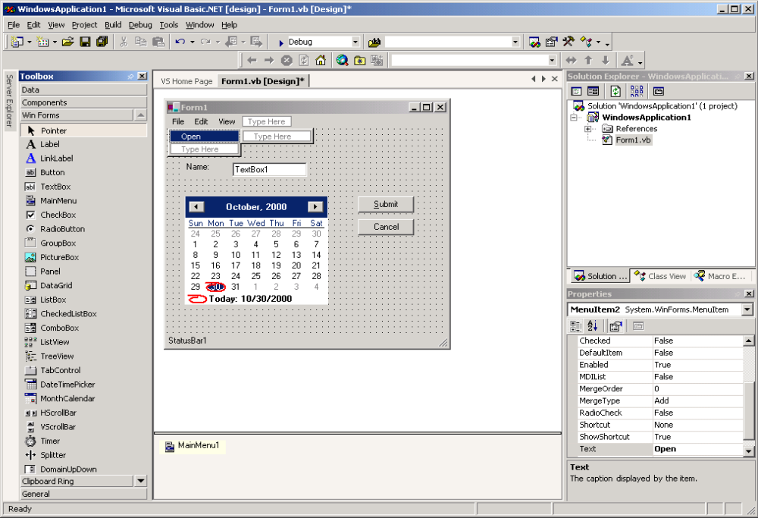
Windows Forms can be built with the Menu Designer.

Visual Inheritance
Visual inheritance is one of the key new features available in Windows Forms that will enhance developer productivity and facilitate code reuse. For example, an organization could define a standard base form that contains items such as the corporate logo and perhaps a common toolbar. This form can be used by developers through inheritance and extended to meet the requirements of specific applications while promoting a common user interface across the organization. The creator of the base form can specify which elements can be extended and which must be used as is, ensuring that the form is reused appropriately.

Precision Form Design
Developers will have an unprecedented level of control and productivity when designing their Windows Forms applications. Features such as the Menu Designer, Control Anchoring, Control Docking and many new controls enable a higher level of power and precision for developers building rich Windows-based user interfaces.
With the Menu Designer, developers can quickly and easily add menus to a form, modify them and view how they look without having to run the application. Controls on the form are more effective with Control Anchoring, enabling a form to automatically resize controls as a user resizes the form. With Control Docking, controls can be docked on any side of a form, providing greater flexibility in layout.
Existing ActiveX controls can be used and run on any form as well, preserving investments in existing technologies.
New controls, including Link Label, Tray Icon and Print Preview, provide additional common functionality for developers. Link Label provides HTML-like linking to a specified URL. Text displayed using this control will appear underlined and the cursor will change to a hand as the mouse moves over it, firing an actionable event when clicked. Tray Icon enables developers to create applications that run in the Windows tray similar to the Microsoft SQL Server Service Manager. Windows Forms offers a printing framework that makes printing simple, including a Print Preview window with the Print Preview control.
Developers can build applications that support the broadest audience of users with Windows Forms. Windows Forms controls implement Microsoft Active Accessibility® programming interfaces, making it straightforward to build applications that support accessibility aids such as screen readers.

Powerful Graphics
Windows Forms applications take advantage of GDI+, the successor to GDI, the graphics device interface included with earlier versions of Windows. GDI+ provides richer image control, including support for more image formats. Developers will be able to easily access high-end graphics features such as alpha blending, manipulating gradient consistency, double-buffering of the OnPaint event, as well as transparent and layered windows enabled by Windows 2000. With these features, developers can create richer, more complex graphical applications.

Lower Total Cost of Ownership
Windows Forms provides more than just a great way to build rich Windows-based applications. Developers also benefit from easy deployment capabilities and an integrated application security model. Windows Forms takes advantage of the versioning and deployment features of the Microsoft .NET Framework to offer reduced deployment costs and higher application robustness over time. This significantly lowers the maintenance costs (total cost of ownership, or TCO) for applications written in Windows Forms.
With a Windows Forms application, there is no need to deploy an application to the end user’s desktop. Instead, users can invoke the application simply by typing a URL in a browser. The application will download to the client machine, run in a secure execution environment and remove itself upon completion.
For organizations that want to physically deploy an application to the desktop, there is no need to go through a resource-consuming installation process — applications can be simply copied to the PC and are ready to go. Windows Forms provides the flexibility to make applications available to end users in the way that is appropriate for each unique business.
Installing your application with Windows Installer reduces TCO, because each time the application is launched from the Start menu (or any shortcut on the desktop, for example) it is checked to see if it is still correctly installed. Should a critical file have been installed, the application will be repaired automatically and the deleted file restored. This makes applications more robust and reduces the number of support calls due to broken installations.

Conclusion
Windows Forms provides developers with a rich set of technologies for building Windows-based applications. Not only are there new controls and features for fine-tuning the user interface, but Windows Forms also provides flexible deployment and integrated security. Developers building Windows-based applications will be more productive than ever with Windows Forms.
Visual Studio .NET will significantly reduce the complexity of creating distributed applications. The key to building successful distributed applications is to focus on the middle tier. The business logic and the bulk of the application occur on middle-tier servers. The Visual Studio .NET development system takes the concept of rapid application development that developers using Visual Basic have used to rapidly assemble Windows-based user interfaces and applies it to constructing middle-tier objects. Key areas include the following:

Rapid Application Development for the Server
Benefit Summary
- Dramatically increase developer productivity
- Quickly access server based resources with the Server Explorer
- Visually build middle-tier business logic with the Component Designer
- Change application behavior on the fly without having to recompile
- Server Explorer
- Server resources
- Setting up and deploying server-based applications with ease
- Run-time tracing for debugging applications after they are deployed
Visual Studio .NET has the tools that developers need to successfully create powerful middle-tier applications. Developers can do the following:
- Guarantee message delivery and cross-platform messaging with Microsoft Message Queuing (MSMQ)
- Write application errors to a shared application event log or schedule a component to wake up at a predetermined time with scheduled tasks
- Read performance characteristics from any computer on the network
- Write components that wake up and execute when the file system changes
- Drag and drop functionality directly into applications (enabling developers to focus on business problems, not on plumbing)

Server Explorer and Component Designer
One of the biggest challenges in writing a middle-tier component is discovering what application services are available on the corporate network. Once found, they can be very difficult to integrate into an application.
In Visual Studio 6.0, discovery of Microsoft SQL Server and Oracle databases was enabled. Further, Visual Studio can manipulate the schema and data in those databases. Using the Data View window, developers can point to a database and then expand nodes to drill down into the structure of the database. Visual Studio also provides a means for modifying the structure of the database. For example, developers can connect to SQL Server to view and modify tables, views and stored procedures.
In Visual Studio .NET, Server Explorer takes a giant step forward from Data View and shows an entire computer including databases, message queues and all the other server elements installed there.
Developers can add certain types of resources from Server Explorer to Visual Studio designers. When one of these items is added to a designer, Visual Studio automatically creates a component that references the specific resource selected. For example, a developer might choose a specific message queue and add it to the Component Designer. Visual Studio would automatically create a message queue component that references that specific queue.
Developers can use Server Explorer to perform administrative tasks on their Microsoft Windows-based services. This includes starting, stopping, pausing and continuing services. The icon next to the service changes depending on the service’s current state.
By default, Server Explorer saves the last configuration used as part of the session and reopens it the next time the user accesses the Server Explorer window. Developers also can save specific configurations by name and switch between them. For example, developers can set up a specific configuration of Server Explorer for each phase of the software development life cycle.

Component Designer Enables Drag-and-Drop Server Programming
In the same way that forms designers enable rapid creation of client applications, the Component Designer, used with the Server Explorer, provides a way to build server-side components quickly and graphically. The Component Designer applies the concepts of RAD forms-based programming to building middle-tier objects — a visual way to build nonvisual objects. Instead of writing lots of server-based code, developers now can drag and drop server components to a design surface that will run on the server, wire it up using the property browser, then double-click to open the code for that object.
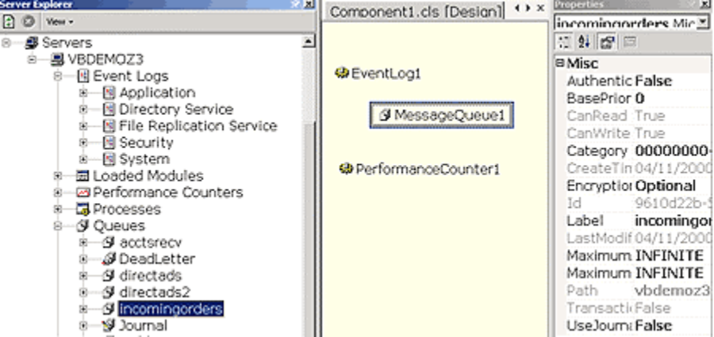
Component Designer
Dragging and dropping components from the Server Explorer eliminates the need for the developer to write potentially hundreds of lines of code, which is now automatically built in to the object that appears in the Component Designer. The developer just programs the object using its properties and methods.

Server Resources

Guaranteed Message Delivery and Cross-Platform Messaging
MSMQ makes it easy for developers to communicate with application programs quickly, reliably and asynchronously by sending and receiving messages. MSMQ provides the following:
- The ability to create applications with disconnected users, such as when a sales force is working remotely
- Guaranteed delivery — for stockbrokers, for example, who may lose millions of dollars if their order entry applications lose even a single order
- Concurrent execution for firing off lots of requests for work
- Automatic logging of activity, which is good for maintaining audit trails and recovering data
- Connection to IBM MQSeries, a popular message queueing system on mainframes and AS/400
Developers need to be able to send and receive messages, create and delete message queues, and manage those queues. With Visual Studio .NET, Server Explorer and the MSMQ component simplify these tasks.
By dragging a message queue from Server Explorer to a component, the default values for the message queues and messages allow developers to send simple messages with one line of code.

mq.Send “Hi Mom”
Receiving a message is just as simple.

Set message = mq.Receive
Developers have two options when programming MSMQ in Visual Studio .NET:
- To send a message, developers need to associate a message object with a message queue. This object allows them to talk directly to the queue and send messages as efficiently as possible.
- To begin programming against an existing queue, developers just drag it to a component, or they can create, delete and rename queues directly in Visual Studio.
The next step is to provide the data to be sent. The user can call the send method on the message queue and the data will be sent to the specified queue.

Dim mq as new MessageQueue (“\\MyMachine\Queue1”)
mq.Send “This is the message”
mq.Send 7
mq.Send myOrder
The MSMQ component will take the data from the argument, persist it into the message and send the message to the specified queue.

Writing Application Errors to a Shared Application Event Log
Applications for the Microsoft Windows NT®, Windows 2000 and Windows XP operating systems routinely write warnings and errors to the event log. Event logging provides a standard, centralized way for Windows and applications to record important software and hardware events. The event log supplies a standard user interface for viewing the logs and a programming interface for examining the logs.
With Visual Studio .NET, developers can drag an event log from Server Explorer to a component and write the application-specific code to read and write to the event log.
Custom event logs also can be created and written. To do this, simply drag an event log component from the toolbox and specify a unique name for it, and it will be automatically created.
Finally, developers can run code when an entry is written to a log. For example, when an error entry is written to an application log, an administrator will be paged.

Scheduling a Component to Wake Up With Scheduled Tasks
Running components at scheduled times is an important requirement for enterprise customers. Businesses run on schedules. Books need to be closed at the end of every business day. Audits need to be performed monthly. Detailed reports need to be available every morning for analysis. These are all examples of scheduled tasks for which automated processing occurs.
For years, Visual Studio has made it easy to build executables and components that run inside the Windows operating system. Now Visual Studio allows developers to build applications and components that can be scheduled to run at predetermined times and intervals.
For example, a chain of retail stores might use scheduled components. At the close of business, the contents of the store’s database must be transferred to corporate headquarters. A scheduled component runs at an assigned time at each store. The scheduled component looks at new sales for the day, packages them and sends them to headquarters. In addition, at 2 a.m., every store performs an inventory analysis. Items falling below a given threshold are reordered from distributors.
To use a scheduled component, developers need only to drag a Scheduled Event component from the toolbox to the Component Designer. Once the Scheduled Event is part of the component, developers can customize it by setting properties in the property window, then double-clicking the component to fill in the code to execute when the component wakes up:

Public Sub SchdEvent1_OnScheduledEventReceive
(EventSource as Object, e as ScheduledEvent)
‘User code goes here…
End Sub

Reading Performance Characteristics From Any Network Computer
Performance monitoring is the process of capturing and analyzing the performance data that applications, services and drivers provide to determine system bottlenecks and fine-tune system and application performance. Windows XP, Windows 2000 and Windows NT provide a means for monitoring system performance through performance counters and the Performance Monitor application. In addition, Performance Monitor can respond to counter values when things such as thresholds are hit. For example, an event can be written to the event log or the computer can be shut down.
Visual Studio .NET provides a component that can easily create new counters and read and write values to any performance counter. One use of this component is reporting the number of orders processed per second. A business object has a property that can be modified after deployment to turn on or off the timing of how long it takes to process a single order. When there are heavy system loads and throughput appears to be diminished, an administrator can turn on this facility and use Performance Monitor to determine how well the application is running. If the administrator finds that the system is under a heavy load and the application cannot process orders quickly enough, resources can be reallocated to boost performance.
To use a Performance Counter component, developers can just drag it from Server Explorer to a component and double-click to write the application-specific code.

Directory Watcher Activates When the File System Changes
A common business practice in use today is to write long-running applications that watch for file changes to kick off a business process. Typically, these consist of a timer control with code to look for file changes at a regular interval. This code is not very efficient. With the Visual Studio .NET Directory Watcher component, creating a more efficient component for this task is easy. The component listens to the system directory change notifications and fires events when a directory, or a file within a directory, changes.
One example of how developers might use this component is with FTP. For example, if a Web-based news site has set up an FTP server, journalists from all over the world can upload their stories to it. When a new story arrives in an FTP directory, a Directory Watcher component notifies editors by electronic mail.
Users simply drag a Directory Watcher component from the toolbox and then set properties to determine when the component should wake up. The component can wake up and execute code when a directory changes, is created or is deleted and when a file is added, renamed or deleted. Developers just double-click the component to write the code to execute when the file or directory event occurs.

Setting Up and Deploying Server-Based Applications With Ease
Corporate administrators face the challenge of deploying the elements of a distributed application and managing them throughout their life cycle. Component developers and solution integrators are tasked with providing sufficient information to administrators and other developers to facilitate application deployment. In a distributed application model, the goal is to make it sufficiently easy for component developers and integrators to provide deployment information, without sacrificing the usefulness of the model for administrators.
The aim of deployment is to easily transport solutions or projects of any size or makeup from the development environment to the production environment. Visual Studio .NET deployment works across multiple computers. It enables N-tier deployment (i.e., deployment to more than one target computer in a single operation). It also eases deployment to Web servers and COM+ servers.

Create Setup Applications That Span All Tiers of an Application
Often developers need to deploy all three tiers of a distributed application, usually written in multiple languages. With the new deployment tools in Visual Studio .NET, creating a multitier setup application is easy.

Use Custom Installers to Set Up Server Resources During Deployment
Incorporating application server functionality into middle-tier components creates a dependency on that server. For example, a developer creates a component and drags and drops a message queue component from the toolbox onto a class. This message queue exists on the developer’s computer. However, when the application is deployed, the queue needs to be created if it doesn’t exist. Visual Studio .NET includes custom installers to help ensure that applications relying on these server-based resources are created when deployed.

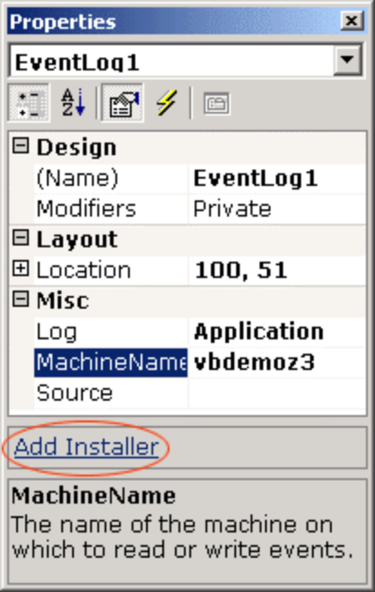

The Add Installer link on the Properties window
The Properties window has a link, Add Installer, that when clicked results in a new class being added to the project containing a Message Queue Installer component. The Message Queue Installer component knows the details of how to create the required queue.

Run-Time Tracing for Debugging Applications After They Are Deployed
Tracing is a feature that allows developers to instrument an application. Such instrumentation allows developers and administrators to monitor the health of deployed applications, as opposed to running a debugger. (Sometimes using a debugger hides bugs and obscures performance and threading problems.) Tracing is a very important monitoring and debugging tool for distributed, multitier applications. Such applications often contain problems that are observed only when an application is under heavy load and the inherent randomness of a real-life environment.
Ideally, developers can include trace instrumentation in their production code with minimal overhead (for example, 10 percent to 15 percent impact on performance and size). When the system does not perform as expected, developers can turn on tracing for their production code while the system is up and running and identify the problem. Tracing lets developers isolate problems and fix them without disturbing a running system.

Dynamic Properties Change Functionality After Deployment
One of the most common problems with production Web applications is that developers need to change the application behavior while the site is running. Visual Studio .NET provides the ability to create dynamic properties that can be modified after application deployment. Values are not hard-coded into the application. Instead they are retrieved at runtime from an XML file each time the application is run. Developers can easily modify this file to alter the behavior of the application without having to write, compile and deploy new code.
Dynamic property values can be modified once the application is deployed and while the application is running. Developers can use a tool such as Notepad or the built-in XML editor in Visual Studio to edit the properties and change property values.
An example of a dynamic property is the connection string to a database. If the application hard-codes the connection string into the application, the developer would need to recompile the application as the application moved from development to test to production. By making the property “dynamic,” the connection string value can be modified after the application is deployed. The next time the application is run, the new value will be used, thereby pointing the application to a different database without modifying the source. Dynamic property settings can be shared by multiple properties in a project so a shared connection string must only be updated in one location.

Conclusion
Visual Studio .NET provides the discovery mechanism for finding databases, message queues, event logs, performance counters and other server resources on a corporate network. Plus, it enables developers to drag these server resources directly onto a “visual class” to begin programming in a graphical way. Quite simply, this means that Microsoft has enabled rapid application development for the server in Visual Studio .NET.
Distributed Web applications can be difficult to set up and deploy. However, with the new tools in Visual Studio, Microsoft provides a setup tool focused on distributing all tiers of a distributed application. And with the new functionality in Visual Studio .NET, developers can build post-deployment debugging and functionality changes right into their applications.

The Web has quickly become the focus for a large amount of development work. Applications such as shopping sites, customer relationship management (CRM) and knowledge management are being built for the Web, and businesses are reaping the benefits of reaching their customers any time and anyplace.

Programmability For Distributed Web Applications
However, Web-based application development is held back by the lack of tools for easily customizing business logic and rules. Imagine a scenario where an independent software vendor (ISV) wants to create a Web version of its CRM product. It wants to sell this to 1,000 companies, each of which has its own specific rules and processes. At one company, a follow-up e-mail is automatically sent after each customer call. Another will not accept new orders if any of its customers have outstanding balances of more than 90 days. How can the ISV deliver a Web-based application that is fine-tuned to the individual needs of all of its customers?
Benefit Summary
- Customizable distributed applications
- Powerful design time based on Visual Studio .NET IDE
- Lightweight scalable run-time
- Customizable middle-tier business logic using full power of Visual Basic .NET
- No need to distribute source code
The answer is Visual Studio for Applications. VSA provides a fully integrated way for customers to seamlessly customize and extend the functionality of Web-based applications using familiar tools. VSA enables developers to modify and extend the business logic of Web applications to fit their individual needs or the needs of their organization. Just as Visual Basic for Applications (VBA) introduced the concept of desktop application customization, VSA extends this concept to distributed .NET applications.

Visual Studio for Applications Design-Time and Run-Time Engines
A key benefit of VSA is its integrated architecture. VSA is built directly into the Web application to provide seamless, secure, controlled access to the application’s business logic. Integration of VSA is a two-step process that enables an application to host the fundamental components of VSA — the design-time and run-time engines. Together, these two components provide a powerful, scalable mechanism for developers to create, deploy and execute custom code within the Web application.
To author and deploy custom code, VSA-enabled applications provide developers with the VSA IDE, a subset of Visual Studio .NET. Within the IDE, developers have secure, direct access to the Web application’s middle-tier business logic. Developers can invoke the VSA IDE on their desktop, seamlessly save and load custom code, and debug their customizations. Customizations are made by writing code that addresses the business logic through an object model, rather than through source code.
To load and execute VSA custom code in a Web application, a lightweight, high-performance run-time engine is provided. ISVs and corporations wanting to integrate VSA will first expose an object model to their middle-tier business objects, then host the VSA run-time engine within these middle-tier objects. The separate run-time engine provides a number of key benefits to developers of Web applications. The VSA run-time engine was designed to be lightweight and extremely scalable on the server to handle the demands of today’s Web applications.
Although it has a small footprint, the run-time engine delivers a powerful mechanism to execute custom code. It uses the same compiler as Visual Basic .NET, enabling developers to write full Visual Basic code behind middle-tier objects to customize and extend their functionality. VSA is built with a language-neutral architecture and future versions will support additional .NET languages.
Once the VSA design-time and run-time engines have been hosted in a Web application, they ship as an integrated part of the application to customers, providing a seamless mechanism for tailoring and extending the business logic of a Web application to meet specific needs.

Distributed Web Applications Become a Development Platform
ISVs and corporations that VSA-enable their Web applications provide developers (both VARs and internal IT staff) with a development platform upon which to extend and customize the applications’ functionality.
Embedding VSA eliminates the need to purchase outside tools to customize applications. The Visual Studio for Applications IDE provides a full, rich environment for writing customization code, using a familiar tool set (Visual Studio .NET) and language (Visual Basic .NET). Companies that need customized Web-based applications can tap into a ready-made work force of millions of developers who already know how to use Visual Basic and, in future versions of VSA, other .NET languages.
VSA custom code is automatically run with no user intervention required to load and execute the developer customization. Custom code is executed when the appropriate middle-tier business logic code is run. If new customizations are written, they are run the next time the middle-tier code is executed. There is no need to take down the server, and users do not need to exit the application to run new custom code.
With Visual Studio for Applications, intellectual property is protected. There is no need to distribute source code to customize the application and its inherent business logic.

License Program
ISVs, corporations and developers that are interested in evaluating Visual Studio for Applications can download the VSA SDK from the VSA Web site at http://msdn.microsoft.com/vstudio/vsip/vsa/. Licensing and integration support is supplied by Summit Software Co., Microsoft’s Authorized Agent for VSA. More information can be found on Summit’s Web site at http://vsa.summsoft.com/.

Summary
Visual Studio for Applications is the first technology that enables ISVs and corporations to easily build customizable distributed applications. Based entirely on the .NET Framework and Visual Studio .NET, Visual Studio for Applications makes a distributed Web-based application a development platform, enabling developers to tailor the application’s business logic to meet their specific needs.
Innovate in Languages
To support the broadest range of developer skills, Microsoft provides a multilanguage platform with support for over 20 different languages. In Visual Studio .NET, Microsoft supplies four key languages: Visual Basic .NET, Visual C# .NET, Visual C++ .NET and JScript® .NET. Third parties will supply such languages as COBOL, FORTRAN, Perl, Python, RPG, Eiffel and Java.
Visual Basic .NET provides easy Windows- and Web-based programming and is the most productive tool in the Visual Studio .NET family. One of the advantages of Visual Basic is its accessibility. Developers with skill levels ranging from hobbyist to mission-critical enterprise developer reach to Visual Basic because of its high productivity. With Visual Basic .NET, developers can easily build XML Web services and applications using .NET. Visual Basic is the easiest language in Visual Studio .NET to learn and read. While Visual Basic .NET is a very accessible language, it also enables developers to take advantage of advanced features such as object-oriented programming (OOP), including inheritance, and structured exception handling. The key value with Visual Basic is that developers can choose when to take advantage of these new language features.
Visual C# .NET provides power and productivity for C++ and Java developers. Visual C# is Microsoft’s implementation of the C# specification submitted to the ECMA standards body. Because the language is in a standards group, other implementations of C# can be created by third parties. Visual C# enables the construction of powerful XML Web services and applications using .NET. This language is derived from C++, but unlike C++ and Java, it provides true properties, events and methods. As C++ developers are accustomed to more under-the-hood control, Visual C# provides the ability to perform “Unmanaged” calls (code that executes outside the .NET Framework).
Visual C++ .NET provides high performance and fine-grained control for hardcore C++ developers. Visual C++ enables developers to build applications that run natively on the operating system. Developers also can target the .NET Framework and common language runtime with Managed Extensions for C++. Because Visual C++ developers can write directly to the operating system, they have the most control, and because they also can write to the .NET Framework, they have the most flexibility. Like Visual Basic and Visual C#, Visual C++ also can create powerful XML Web services.
JScript .NET is Microsoft's implementation of the ECMA 262 language. JScript .NET is primarily used for building Web sites with ASP.NET and for customizing applications with Script for the .NET Framework. Combining the existing feature set of "classic" JScript with the best features of class-based languages, JScript .NET, gives you the best of both worlds. Improvements in JScript .NET, which is being developed in conjunction with ECMAScript Edition 4, include true compiled code, typed and typeless variables, classes (with inheritance, function overloading, property accessors and more), packages, cross-language support and access to the .NET Framework.
Visual Studio .NET provides a single shared development environment that helps developers build their solutions faster and with access to key productivity features regardless of the programming language used. It combines a consistent RAD paradigm for application design, intuitive tools for server-based development, and a new unified IDE to speed and simplify the design, development, debugging and deployment of XML Web services and applications.
Visual Basic has always been a fast, productive way to create applications for Windows. But for the past few years, developers who needed to quickly write Web applications have been wondering, “Where is Visual Basic for the Web?”

Visual Basic .NET: Productivity and power
The wait is finally over.
In addition to being better than ever at creating solutions for Windows-based clients and servers, Visual Basic .NET is now the fastest and most productive way to create Web applications and XML Web services.
Benefit Summary
- Maximize code reuse with inheritance
- Streamline error handling with structured exception handling
- Create high-performance applications with free-threaded programming model
- Take advantage of the .NET Framework
- Maintain simplicity using only the features you desire
- Leverage existing investments with the upgrade tool
The technologies in the .NET Framework and in Visual Studio .NET have solved some of the most persistent problems facing developers using Visual Basic — problems such as deployment and versioning components. Developers using Visual Basic now have full implementation inheritance and visual inheritance for forms. Thanks to Windows Forms, developers now have a much simpler way to directly access many of the advanced features of Windows. In addition, Visual Basic has delivered on long-time feature requests such as the ability to build Windows NT Services and console applications.
Since these improvements have been discussed earlier in the guide, the rest of this section focuses on the language innovations specific to Visual Basic .NET.

Language Innovations
To rapidly build enterprise Web applications, developers must rely on business logic that is scalable, robust and reusable. The language improvements in Visual Basic .NET were designed to enable development and deployment of reliable and scalable Web applications.
First and foremost, Visual Basic is now a first class object-oriented programming language, with full support for features such as implementation inheritance and structured exception handling.
In addition to being modernized, the Visual Basic language also has been updated to make it even more user-friendly. Features that existed only for historical reasons have been removed to simplify the language. Language syntax has been updated to be more logical and understandable. It is now easier to read code and understand what that code will do.
With these new language features, Visual Basic delivers power while maintaining the instant accessibility that has made it the world’s most popular development tool.

Inheritance
Consistently, the No. 1 most requested feature for Visual Basic is support for implementation inheritance. Developing in Internet time requires rapid assembly and massive reuse. Visual Basic now includes full implementation inheritance, including visual form inheritance.
Developers can use the new keyword “Inherits” to derive from an existing class.

Class1
Function GetCustomer()
...
End Function

Class2
Inherits Class1
Function GetOrders()
...
End Function

The Inherits statement supports all the usual properties associated with inheritance.
Instances of the derived class support all methods and interfaces supported by the base class. In addition, the derived class can extend the set of methods and interfaces supported by the base class.
The derived class can override methods defined in the base class using the “Overrides” keyword. To reduce programming errors, Visual Basic prevents developers from accidentally overriding a function; only functions that are declared “Overridable” are allowed to be overridden in derived classes.

Overloading
Visual Basic .NET also allows function overloading, which gives developers the ability to create different versions of a Sub or Function that have the same name, but different argument types.
Overloading is especially useful when an object model dictates that the developer employ similar names for procedures that operate on different data types. For example, a class that can display several different data types could have Display procedures that look like this:

Overloads Sub Display (theChar As Char)
...
Overloads Sub Display (theInteger As Integer)
...
Overloads Sub Display (theDouble As Double)
Without overloading, developers would have to create distinct names for each procedure or use a Variant parameter. Overloading provides a more explicit and efficient way to handle multiple data types.

Parameterized Constructors
Parameterized constructors (or more simply “constructors”) allow developers to create a new class instance while simultaneously passing arguments to the new instance. Constructors are essential for object-oriented programming because they allow user-defined construction code to be passed through a set of parameters by the creator of the instance. They simplify client code by allowing a new object instance to be created and initialized in a single expression.

Free Threading
When developers create applications in Visual Basic, the code that they write is synchronous, which means that each line of code must be executed before the next one. When developing Web applications, scalability is key. Developers need tools that enable concurrent processing.
With the inclusion of free threading, developers can spawn a thread, which can perform some long-running task, execute a complex query or run a complex calculation while the rest of the application continues — providing true asynchronous processing.

Sub CreateMyThread()
Dim b As BackGroundWork
Dim t As Thread
b = New BackGroundWork()
t = New Thread(New ThreadStart(AddressOf b.Doit))
t.Start
End Sub
Class BackGroundWork
Sub DoIt()
…
End Sub
End Class

Structured Exception Handling
Developing enterprise applications requires the construction of reusable, maintainable components. One challenging aspect of Visual Basic in past versions was its support for error handling. Developers have found that a consistent error-handling scheme means a great deal of duplicated code. Error handling using the existing On Error GoTo statement sometimes slows the development and maintenance of large applications. Its very name reflects some of these problems: As GoTo implies, when an error occurs, control is transferred to a labeled location inside the subroutine. Once the error code runs, it must often be diverted via another cleanup location via a standard GoTo, which finally uses yet another GoTo or an Exit out of the procedure. Handling several different errors with various combinations of Resume and Next quickly produces illegible code and leads to frequent bugs when execution paths aren’t completely thought out.
With Try...Catch…Finally, these problems go away. Developers can nest their exception handling, and there is a control structure for writing cleanup code that executes in both normal and exception conditions.

Sub SEH()
Try
Open “TESTFILE” For Output As #1
Write #1, CustomerInformation
Catch
Kill “TESTFILE”
Finally
Close #1
End try
End Sub

Additional Modernized Language Features
Microsoft has added a number of additional constructs that simplify the development of more robust, scalable applications. These features include providing strict type checking in the language, productivity features such as initializers and delegates. The language has been extended to make Visual Basic more comprehensive.

Strict Type Checking
Today Visual Basic is liberal with the implicit-type of coercions that it will generate. For assignment and for parameter passing other than by reference, the Visual Basic compiler will allow nearly any data type to be converted to any other type by generating run-time coercions. The run-time coercion operation will fail if a value cannot be converted without data loss. Through the addition of a new compilation option, Visual Basic .NET can generate compile-time errors for any conversions that may cause an error at runtime. Option Strict improves type safety by generating errors when a conversion is required that could fail at runtime or that, like the automatic conversion between numeric types and strings, is unexpected by the user.

Shared Members
Shared Members are data and function members of classes that are shared by all instances of the class. Sharing a single instance of a data member or function among all instances of a class is required in a Visual Basic with inheritance. A shared data member exists independently of any particular instance of the class. A shared method is a method that, unlike normal methods, is not implicitly passed during an instance of the class. For this reason, no unqualified references to nonshared data members is allowed in a shared method. Public shared members can be late-bound from an instance of the class.

Initializers
Visual Basic .NET supports initialization of variables on the line in which they are declared. Initializers can be used anywhere, including inside a control structure. The semantics of a procedure-level declaration, which includes an initializer, are the same as a declaration statement immediately followed by an assignment statement. In other words, this statement:

Dim X As Integer = 1
is equivalent to these statements:

Dim X As Integer
X = 1

Upgrading From Visual Basic 6.0
Visual Basic .NET represents a major shift from earlier versions of Visual Basic. To take advantage of the .NET Framework, many areas of the product have been modernized, including the language, development environment and file formats. Consequently, projects created in earlier versions of Visual Basic may not be compatible with Visual Basic .NET.
Visual Basic .NET provides several features to help developers move their projects forward from Visual Basic 6.0 so that they can continue development and take advantage of the features in Visual Studio .NET and the .NET Framework.
In addition, Visual Studio .NET provides features to help developers quickly learn the differences between Visual Basic 6.0 and Visual Basic .NET, so they can become quickly productive.
Because of the seamless COM support in the .NET Framework, developers can maintain their existing components in Visual Basic 6.0 and easily target those components from new code written in Visual Basic .NET. As needed, and on the developer’s desired schedule, those components can be moved forward into Visual Basic .NET.

The Upgrade Tool
Visual Basic .NET includes a wizard to help developers upgrade their Visual Basic 6.0 projects. Invoked when the developer first opens a Visual Basic 6.0 project in Visual Basic .NET, the wizard presents options for controlling the upgrade process.
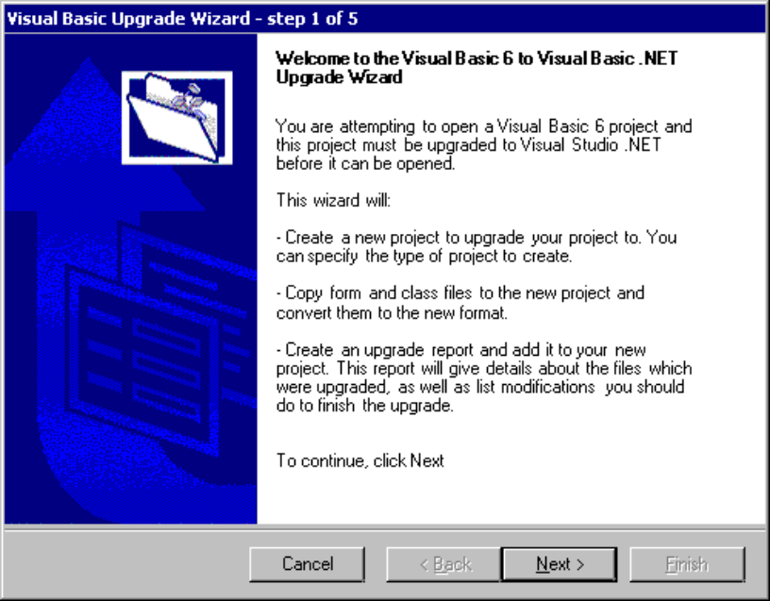
Upgrade Wizard
When run, the wizard creates a new Visual Basic .NET version of the project, leaving the original Visual Basic 6.0 version untouched.
Because of the language and form package differences between the versions of Visual Basic, most projects can’t be automatically upgraded with 100 percent fidelity. The upgrade wizard helps identify the areas requiring attention by providing a detailed report showing any code that will need to be manually fixed up.
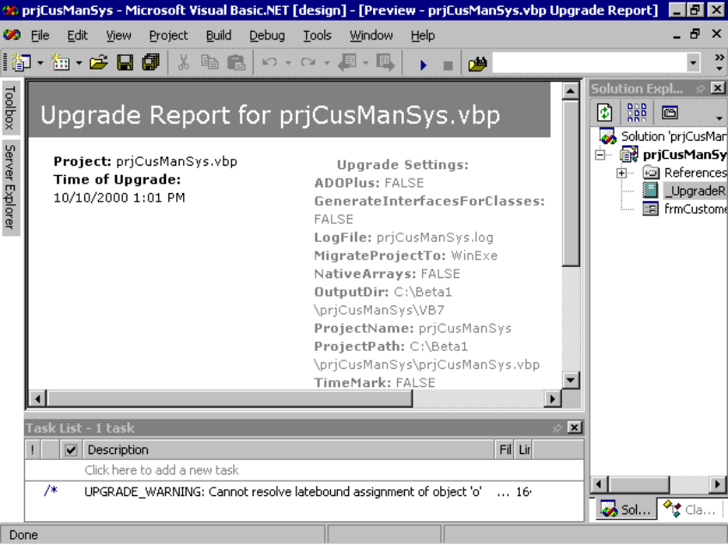
Upgrade Report
Any required changes (i.e. code that will cause compiler errors) show up in the Task List, giving the developer a checklist to work from. The report also includes warnings to point out any code that, while not restricting the compiling process, might cause other potential errors. Finally, suggestions are added to the report for where code might be improved through modifications that take advantage of new .NET Framework capabilities.
For each error, warning or suggestion in the report, a direct link is provided to a Help topic that gives a detailed explanation of the problem as well as an outline of the steps required to fix it. As developers work through the items in the report, they also learn about many of the new features of Visual Basic .NET.

Knowledge Upgrade
As with any upgrade, developers can expect to invest some time in learning the new concepts and features in Visual Basic .NET. Extensive help is provided in the form of documentation that details the changes between the two versions, and this is aimed specifically at developers who are upgrading. For each change in the product, a help topic is provided explaining “if you did X in Visual Basic 6.0, here’s how you do it in Visual Basic .NET”.
For example, developers using Visual Basic 6.0 frequently used control arrays to handle related events for a group of controls. Control arrays are not supported in Visual Basic .NET because of the architecture of the .NET Framework; a help topic is provided showing how to achieve the same result using delegated events.

Conclusion
Visual Basic is now a first-class object-oriented programming language and a first-class language citizen on the .NET Framework. Developers will be able to create highly scalable code with explicit free threading. The code they write will be highly maintainable with the addition of modernized language constructs such as structured exception handling. Visual Basic .NET provides all the language characteristics that developers need to create robust, scalable distributed applications and services.

Visual C++ .NET contains a wealth of new and enhanced features that enable developers to create and consume Web applications and XML Web services. Visual C++ .NET strives to help developers produce smaller, faster and more functional programs in less time.

Visual C++ .NET: Performance and Control
Developers typically choose C++ as a development language because it provides them with more power and flexibility than other development environments. C++ developers want maximum control over the components that make up their application, and they expect their development tools to produce the most compact and best-performing programs possible. Visual C++ .NET makes it easier for developers to achieve these goals.
Benefit Summary
- Reduce the amount of code you write with attributes
- Integrate existing applications with the .NET Framework using managed extensions for C++
- Create high-performance XML Web services infrastructure with ATL Server
- Write more robust code with error correcting features
- Create powerful applications with the enhanced optimizing compiler

Power and Flexibility
Visual C++ is unique among the .NET languages in that it supports both the managed code model provided by the .NET Framework and the unmanaged native Windows code model. By supporting both programming models, Visual C++ .NET preserves and enhances existing investments and provides the maximum possible choice for developers.
Visual C++ .NET includes a very powerful extension to Active Template Library (ATL), called ATL Server, that helps developers create compact, high-performance Web applications and services. ATL Server takes the best practices for developing high-performance Web applications and encapsulates them into a set of simple and extensible ATL classes for developers to reuse.
Enhancements to Visual C++ make it easy for client-side or server-to-server programs to invoke other XML Web services, whether developers are using the .NET Framework, Microsoft Foundation Classes (MFC), ATL or programming directly to the Windows APIs.
With the new Managed Extensions for Visual C++, developers can write C++ programs that target the .NET Framework. The Managed Extensions also act as a bridge between Visual C++ code and any managed language, including Visual C# .NET and Visual Basic .NET.
Visual C++ .NET also includes a number of features that make it easier to maintain and enhance existing Windows-based applications. Updates to MFC give developers access to the latest Windows platform enhancements. Visual C++ continues to maintain its leadership in the quality and performance of the code it generates. In addition, new optimizations to the compiler offer smaller and faster code than in previous releases.

ATL Server: XML Web Services in Visual C++ .NET
When developers choose to write portions of their Web applications in C++, they usually do so for reasons of performance or control. Web solutions written in ASP.NET perform and scale very well and generally offer more power than needed for most Web applications. There are times, however, when developers need more performance than a C++ implementation can provide or when they will want complete control over every bit of code in a critical component. ATL Server is designed for exactly those situations.
ATL Server takes the best practices for developing high-performance Web applications and encapsulates those practices into a set of simple and extensible ATL classes for developers to reuse. ATL Server includes features to make Web applications and XML Web services scale out across machines on a Web server farm.

How ATL Server Works
ATL Server encourages the creation of Web applications in a modular fashion. An application can be a combination of plain HTML files and specially marked “stencil” HTML files, which are given an .sfr extension (for “server response file”). HTML in the stencil file looks like this:

<body>
<p>{{HelloWorld}}</p>
</body>
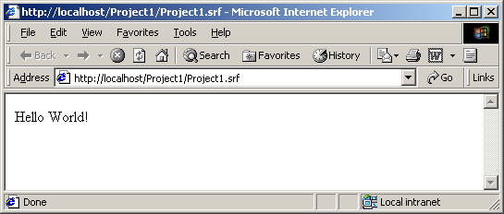
The double curly braces around “HelloWorld” mark it as a tag that requires special processing. ATL Server processes the stencil file and converts the tags into method calls on the object associated with the HTML page. When the method returns the string “Hello World!” then the HTML page renders like so:

Simple ATL Server application
In addition to plain HTML and SRF files, developers also can mix ATL Server pages with ASP and ASP.NET pages in the same application. This allows developers to mix and match implementation technology based on their particular needs.
XML Web services written with ATL Server are similar to ATL Server-based Web applications. Rather than calling in to Visual C++ objects based on the tags in a page, an XML description is sent to the server telling ATL Server what method to call. ATL Server converts the return value from the function into XML and returns that to the caller.
Although the frameworks are different, XML Web services written with ASP.NET and ATL Server behave in exactly the same way with respect to the client. Because of the consistent model, developers can use whichever framework works best for their project and client programs are unaffected.

Performance and Scalability
ATL Server greatly simplifies the process of writing high-performance and scalable Web applications. ATL Server applications run inside of IIS as ISAPI dynamic-link libraries (DLLs). The DLL for an application is loaded only once on the first invocation, and every successive invocation is a simple and very efficient function call.
ATL Server also has built-in support for thread pooling, which further increases performance and increases server availability. Because IIS only has a limited number of threads for handling incoming requests, ATL Server creates its own pool of threads to use when generating the page that will be returned back to the client. The request from IIS is handed off to this separate thread pool in which the developer’s object is invoked to create the page. The result is then handled back to IIS to return to the client.
This architecture enables Web applications and XML Web services written with ATL Server to scale up very well and is completely transparent to the client. Because every server application has different performance requirements, a key benefit for developers is that the thread pooling, along with the other components of ATL Server, can be precisely tuned based on the exact needs of the application.
ATL Server also offers many additional services. An example is the ability to store a session state between client requests. Support is included for storing session states in a database, which makes it much easier to write a Web application that will run on a server farm. Since the session state is stored in the database and not tied to any one machine, different machines in the Web farm can handle successive requests from the same client. Whether you store session states in memory, a database or somewhere else, the ATL Server classes hide the details. This means that developers can start out saving a session state in memory for simplicity and then easily move the session state to a database as the application needs to scale.

Great Server Application Support
ATL Server has a number of other features designed specifically with server applications in mind. There is a small and very efficient HTTP client designed for server-to-server applications. The HTTP client allows developers to invoke other XML Web services from their server code without the overhead of larger, client-focused HTTP implementations.
ATL Server also includes classes that help developers generate simple HTML constructs from code and a simple SMTP mailer facility that allows, for example, mailing server status messages to another machine or sending an order confirmation to a customer.
ATL Server includes built-in performance counters that allow users to measure basic statistics like page-hit counts without writing any additional code. Also included are classes that make it easy to create performance counters that plug in to the Windows 2000 performance monitor service. Developers can create custom performance counters that measure application-specific performance information and then monitor those statistics from any client on the network using the standard Windows 2000 monitoring tools.

Completely Configurable
Because complete source code is included, developers are free to completely configure and modify ATL Server per their own particular requirements.
In addition, ATL Server is designed in a modular way so that many of the key components, such as thread management and session state management, are particularly easy to customize. Developers can replace only those individual pieces and use the rest of the framework unmodified.

Managed Extensions for C++
Managed extensions for C++ are a set of language extensions that help developers using Microsoft Visual C++ write applications for the .NET Framework.
The managed extensions are useful for the following:
- To enhance developer productivity by using C++ to write .NET Framework applications
- To migrate a large body of code, in stages, from unmanaged C++ to the .NET Framework
- To use unmanaged C++ components from .NET Framework applications
- To use .NET Framework components from unmanaged C++
- To mix unmanaged C++ code and .NET Framework code in the same application
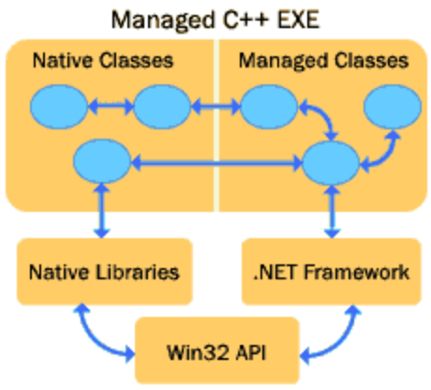
Managed extensions for C++ offer unparalleled flexibility to developers targeting the .NET Framework. Traditional unmanaged C++ and managed C++ code can be mixed freely within the same application. New applications written with managed extensions can take advantage of the best of both worlds. Existing components can be wrapped easily as .NET Framework components by using the managed extensions, preserving investment in existing code while integrating with the .NET Framework.

What Are Managed Extensions?
The Managed Extensions allow developers to write managed classes in C++ that run on the .NET Framework. (References to “unmanaged C++ classes” or “unmanaged C++” refer to traditional C++ code that runs directly in the traditional Windows-based environment and not on the .NET Framework.) Managed classes can take full advantage of the .NET Framework.
The managed extensions are new keywords and attributes in the Visual C++ development system. They allow the developer to designate which classes and functions to compile as managed or unmanaged code. These pieces then interoperate smoothly with each other and external libraries.
Managed extensions also are used to express .NET Framework types and concepts directly in C++ source code.
Smooth Migration of Existing Code to the .NET Framework
If developers have a large investment in C++ code, managed extensions will help them make a smooth transition to the .NET Framework, at whatever pace necessary. Because developers can mix unmanaged and managed code in the same application — even in the same file — they can move code over time, component by component, to the .NET Framework. Or they can continue to write components in unmanaged C++, taking advantage of the full power and flexibility of the language, and only use managed extensions to write thin, high-performance adapters that make their C++ code callable from .NET Framework components.
Accessing a C++ Component From a .NET Framework Language
Managed extensions allow users to call a C++ class from any .NET Framework language. Developers need to write a simple wrapper class using the extensions that expose their C++ class and methods as a managed class. The wrapper is a full managed class and can be called from any .NET Framework language. The wrapper class acts as a mapping layer between the managed class and the unmanaged C++ class. It simply passes method calls from the .NET Framework world directly into the unmanaged class. The managed extensions can be used to call any native DLL as well as native classes.
Accessing .NET Framework Classes From Native Code
Using managed extensions, developers can create and call a .NET Framework class directly from C++ code. Developers can write C++ code that treats the .NET Framework component like any other managed C++ class. They also can use the native COM support in the .NET Framework to call .NET Framework classes. Whether developers use COM or the managed extensions to access .NET Framework components will depend on their project. In some cases, leveraging the existing COM support will be the best option. In other cases, it may be possible to increase performance and developer productivity by using the managed extensions.
Managed and Native Code in One Executable
The Visual C++ .NET compiler translates data, pointers, exceptions and instruction flow between managed and unmanaged contexts automatically and transparently. This process is what allows managed extensions to interoperate seamlessly with unmanaged C++ code. The developer is given fine-grained control over what data and code should be managed.
The ability to choose whether each class and function is managed or unmanaged gives developers great flexibility. Some types of code or data will perform better in an unmanaged environment. On the other hand, managed code typically offers enhanced developer productivity because of features such as garbage collection and self-describing components. Existing unmanaged C++ code can be converted to managed code one section at a time, thus preserving the existing investment.

Attributed Programming
Attributed programming is an enhancement to the C++ language that enables developers to focus on the logic of their code, instead of implementation details. In some cases, such as with Interface Definition Language (IDL), it eliminates the need for external description files, helping ease maintenance concerns. As a result, attributes serve to increase the productivity of C++ developers.
Benefits provided by this new technology include the following:
- A familiar calling convention that conforms to the classic structure of the C++ language
- Easy derivation from base classes without burdensome implementation details
- Replacement of large amounts of source code with a few simple declarations
Attributes simplify the development process by automatically generating code for the developer. As with ATL or MFC, the generated code is always accessible to developers should they need to understand exactly what operations their code is executing.

Attribute Types
Because attributes are intended to encapsulate domain concepts in a declarative way, there are several categories of attributes:
- ATL Server attributes assist in writing high-performance Web applications with ATL Server. For example, these attributes are used to mark methods as XML Web services methods.
- COM attributes simplify numerous areas of COM development.
- IDL attributes create or modify the associated IDL file from within a source code file without a wizard and without being familiar with the structure and syntax of that file. By placing IDL attributes in the C++ source file, developers can keep the information in a single location for easier maintenance.
- Data Access attributes will automatically add code, based on the OLE DB Consumer Templates, that creates a working OLE DB consumer class. The auto-generated code performs tasks such as opening tables, executing commands and accessing data.
- Eventing attributes encapsulate different eventing models into a common interface to make it easier for developers to handle several different kinds of events in a standard way.

Using Attributes
Attributes are used by manually entering them into source code or by using Visual C++ wizards that automatically insert attributes. For example, to implement a simple event sink for a generic ATL class, developers could manually add the event_receiver attribute to a class such as CMyReceiver below. The attribute then is compiled by the Microsoft Visual C++ compiler, which replaces the attribute with the proper code and inserts it directly into the object file.
[event_receiver(com)]
class CMyReceiver {
void handler1(int i) { ... }
void handler2(int i, float j) { ... }
}
Developers then can set up the CMyReceiver methods handler1 and handler2 to handle events from an event source.
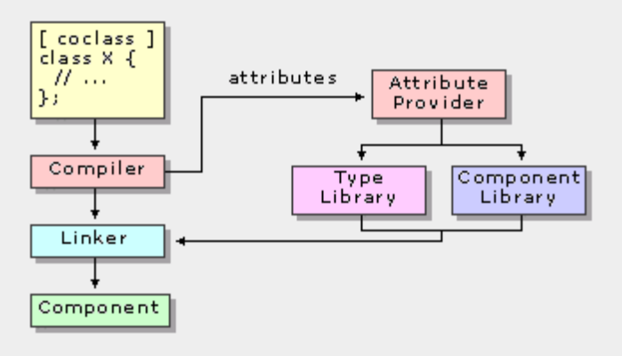
At build time, the compiler will recognize the presence of attributes in a source file and be able to dynamically parse and verify them. As before, when the project is built, the compiler parses each C++ source file, producing an object file. However, when the compiler encounters an attribute, it is parsed and syntactically verified. The compiler then dynamically calls an attribute provider to insert code or make other modifications at compile time.
The following figure demonstrates the relationship between the compiler and the attribute provider.
Attribute usage does not alter the contents of the source file. Developers can generate a separate file for each source file in the project, which displays the results of the attribute substitution. This allows them to examine the code that the compiler is generating for them.
Like most C++ constructs, attributes have a set of characteristics that defines their proper usage. This is referred to as the context of the attribute and is addressed in a table for each attribute reference topic. For example, the coclass attribute can be applied only to an existing class or structure, as opposed to the cpp_quote attribute, which can be inserted anywhere within a C++ source file.
Attributes are used extensively in new Visual C++ .NET features such as ATL Server. They enable developers to write less code and to develop in a more declarative way. Attributes simplify the development process by allowing developers to focus on the logic of their code, instead of implementation details.

Writing Robust Code
Visual C++ .NET includes a new facility for detecting when a developer inadvertently writes data past the end of a buffer — an error known as “buffer overrun.” These are some of the most common errors that cause code to crash and also some of the main ways used to attack Web servers on the Internet.
Visual C++ .NET can be configured to verify the integrity of data written to a dynamically allocated buffer. Developers can write a custom handler that will be invoked if a buffer overrun occurs. This allows the developer to cleanly shut down the application rather than risk undetermined behavior.

Pure Performance
The Visual C++ .NET compiler, already one of the best in the world at generating small and fast code, includes a new improvement called “Whole Program Optimization.” Since the C++ compiler compiles source files one at a time, it previously has only been able to optimize within a single file. The compiler and linker now communicate to enable optimization across multiple source files. This enables the compiler to make improvements to code across the whole program that weren’t possible before.
The compiler also includes a number of other code-generation enhancements, including improved function inlining, that create smaller and faster executable files.

Better Windows Support
MFC has been updated to include support for HTML dialogs that look like the new “Add/Remove Programs” dialog in Windows 2000. MFC also supports the common controls and print dialogs in Windows 2000 and Windows Millennium Edition operating systems. MFC also enables developers to use windowless controls, which can increase form performance.

New Core ATL classes
Some of the core classes from MFC, including CString, CFile, CRect and CPoint, are now useable in ATL (without requiring the MFC runtime). This enables developers to use these core classes in server-side applications without needing to include MFC, which is focused on developing applications for the client. Other new features include better support for the Windows 2000 security, encryption and Active Accessibility programming interfaces. These are all designed to work in an ATL Component, an ATL Server Web Application or an MFC Application.

Conclusion
For developers who require a high degree of control over their code, Visual C++ .NET includes a rich feature set that enables developers to write .NET Framework applications and services with the highest performance and scalability. Visual C++ .NET also includes many enhancements that will improve existing code.

For the past two decades, C and C++ have been the most widely used programming languages for developing commercial and business software. While both languages provide programmers with a tremendous amount of fine-grained control, this flexibility comes at a cost to productivity. Compared with a language such as Microsoft Visual Basic, equivalent C and C++ applications often take longer to develop. Because of the complexity and long cycle times associated with these languages, many C and C++ programmers have been searching for a language that offers better balance between power and productivity.

Visual C# .NET: Modern component-oriented language
Benefit Summary
- Increased productivity for the C and C++ developer
- Ability to build .NET components, XML Web services and Web applications
- Ability to develop programs that are more resilient and robust
- Built-in support for versioning
- First-class support for building software components
- Automatic garbage collection to eliminate the most common memory management errors
- Clean language design, enabling developers to write simpler, more understandable code
Some languages raise productivity by sacrificing the flexibility that C and C++ programmers often require. Such solutions constrain developers too much (for example, by omitting a mechanism for low-level code control) and provide least-common-denominator capabilities. They don’t easily interoperate with preexisting systems, and they don’t always mesh well with current Web programming practices.
The ideal solution for C and C++ programmers is rapid development combined with the power to access all the functionality of the underlying platform. They want an environment that is completely in sync with emerging Web standards and that provides easy integration with existing applications. In addition, C and C++ developers require the ability to code at a low level when and if the need arises.
The Microsoft solution to this problem is C#. C# is a modern, object-oriented language that enables programmers to quickly build a wide range of applications for the Microsoft .NET Framework, which provides tools and services to take advantage of the latest advances in computing and communications.
Because of its elegant object-oriented design, C# is a great choice for architecting a wide range of components, from high-level business objects to system-level applications. Using simple C# language constructs, components can be converted into XML Web services, enabling invocation from across the Internet, from any language running on any operating system.
More than anything else, C# is designed to bring rapid development to the C++ programmer without sacrificing the power and control that have been a hallmark of C and C++. Because of this heritage, C# has a high degree of fidelity with C and C++. Developers familiar with these languages can quickly become productive in C#.
Visual C# .NET is provided as part of Microsoft Visual Studio .NET. It provides access to the Microsoft .NET Framework, which includes a common execution engine and a rich class library. The Microsoft .NET Framework defines a common language specification (CLS), a sort of lingua franca that ensures seamless interoperability between CLS-compliant languages and class libraries. For developers, this means that although Visual C# .NET is a new language, it has complete access to the same rich class libraries that are used by seasoned tools such as Visual Basic .NET and Visual C++ .NET.

Hello, World
The canonical “Hello, world” program can be written in C# as follows:
using System;
class Hello
{
static void Main() {
Console.WriteLine(“Hello, world”);
}
}
The source code for a C# program is typically stored in one or more text files with a file extension of .cs, as in hello.cs.
Close examination of this program is illuminating.
The using System; directive references a namespace called System that is provided by the Microsoft .NET Framework class library. This namespace contains the Console class referred to in the Main method. Namespaces provide a hierarchical means of organizing the elements of a class library. A “using” directive enables unqualified use of the types that are members of the namespace. The “Hello, world” program uses Console.WriteLine as a shorthand for System.Console.WriteLine.
The Main method is a member of the class Hello. It has the static modifier, and so it is a method on the class Hello rather than on instances of this class.
The main entry point for a program — the method that is called to begin execution — is always a static method called Main.
The “Hello, world” output is produced through the use of a class library. The language itself does not provide a class library. Instead, it uses a common class library that also is used by languages such as Visual Basic and Visual C++.
For C and C++ developers, it is interesting to note a few things that do not appear in the “Hello, world” program.
The program does not use a global method for Main. Methods and variables are not supported at the global level; such elements are always contained within type declarations (e.g., class and struct declarations).
The program does not use either “::” or “->“ operators. The “::” is not an operator at all, and the “->“ operator is used in only a small fraction of programs. The separator “.” is used in compound names such as Console.WriteLine.
The program does not contain forward declarations. Forward declarations are never needed because declaration order is not significant in C#.
The program does not use #include to import program text. Dependencies among programs are handled symbolically rather than textually. This system eliminates barriers between programs written in different languages. For example, the Console class could be written in another language.

Types
C# supports two kinds of types: value types and reference types. Value types include simple types (e.g., char, int, and float), enum types and struct types. Reference types include class types, interface types, delegate types and array types.
Value types differ from reference types in that variables of the value types directly contain their data, whereas variables of the reference types store references to objects. With reference types, it is possible for two variables to reference the same object and, thus, for operations on one variable to affect the object referenced by the other variable. With value types, the variables each have their own copy of the data, and it is not possible for operations on one to affect the other.

Predefined Types
C# provides a set of predefined types, most of which will be familiar to C and C++ developers. Types include object, string, int, long, byte and temporal types.
Each of the predefined types is shorthand for a system-provided type. For example, the keyword int is shorthand for a struct named System.Int32. The two names can be used interchangeably, though it is considered good style to use the keyword rather than the complete system type name.

Array Types
Arrays may be single-dimensional or multidimensional. Both “rectangular” and “jagged” arrays are supported.

Type System Unification
C# provides a “unified type system.” All types — including value types — derive from the type object. It is possible to call object methods on any value, even values of “primitive” types such as int.
This type system unification provides value types with the benefits of objectness without introducing unnecessary overhead. For programs that don’t need int values to act like objects, int values are simply 32-bit values. For programs that need int values to behave like objects, this capability is available on demand. The ability to treat value types as objects bridges the gap between value types and reference types that exists in most languages. For example, a Stack class can provide Push and Pop methods that take and return object values.
public class Stack
{
public object Pop() {...}
public void Push(object o) {...}
}
Because C# has a unified type system, the Stack class can be used for stacks of any type, including value types such as int.

Classes
Class declarations define new reference types. One class can inherit from another class and can implement zero or more interfaces.
Class members can include constants, fields, methods, properties, indexers, events, operators, constructors, destructors and nested type declarations. Each member has an associated accessibility, which controls the regions of program text that are able to access the member. There are five possible forms of accessibility.

Form | Intuitive meaning
public | Access not limited
protected | Access limited to this program or types derived from the containing class
internal | Access limited to this program
protected internal | Access limited to this program or types derived from the containing class
private | Access limited to the containing type

Fields
A field is a member that represents a variable associated with an object or class.

Methods
A method is a member that implements a computation or action that can be performed by an object or class. Methods have a list of formal parameters (which may be empty) and a return value (or void), and they are either static or nonstatic. Static methods are accessed through the class. Nonstatic methods, which are also called instance methods, are accessed through instances of the class.

Properties
A property is a member that provides access to an attribute of an object or a class. Examples of properties include the length of a string, the size of a font, the caption of a window and the name of a customer. Properties are a natural extension of fields. Both are named members with associated types, and the syntax for accessing fields and properties is the same. However, unlike fields, properties do not denote storage locations. Instead, properties have accessors that specify the statements to execute in order to read or write their values.
Properties are defined with property declarations. The first part of a property declaration looks quite similar to a field declaration. The second part includes a get accessor or a set accessor. In the example below, the Button class defines a Caption property.

public class Button
{
private string caption;
public string Caption {
get {
return caption;
}
set {
caption = value;
Repaint();
}
}
}
Properties that can be both read and written, such as the Caption property, include both get and set accessors. The get accessor is called when the property’s value is read; the set accessor is called when the property’s value is written. In a set accessor, the new value for the property is given in an implicit parameter named value.
Declaration of properties is relatively straightforward, but the true value of properties shows itself is in use rather than in declaration. The Caption property can be read and written in the same way that fields can be read and written:
Button b = new Button();
b.Caption = “ABC”; // set
string s = b.Caption; // get
b.Caption += “DEF”; // get & set

Events
An event is a member that enables an object or class to provide notifications. A class defines an event by providing an event declaration, which looks quite similar to a field or event declaration but with an added event keyword. The type of this declaration must be a delegate type.

Indexers
An indexer is a member that enables an object to be indexed in the same way as an array. Properties enable field-like access, whereas indexers enable array-like access.
As an example, consider the Stack class presented earlier. This class might want to expose array-like access so that it is possible to inspect or alter the items on the stack without performing unnecessary Push and Pop operations. The Stack is implemented as a linked list, but wants to provide the convenience of array access.

Destructors
A destructor is a member that implements the actions required to destruct an instance of a class. Destructors cannot take parameters, cannot have accessibility modifiers and cannot be called explicitly. The destructor for an instance is called automatically during garbage collection.

Inheritance
Classes support single inheritance, and the type object is the ultimate base class for all classes.

Structs
The list of similarities between classes and structs is long. Structs can implement interfaces and can have the same kinds of members as classes. Structs differ from classes in several important ways, however. Structs are value types rather than reference types, and inheritance is not supported for structs. Struct values are stored either “on the stack” or “inline.” Careful programmers can sometimes enhance performance through judicious use of structs.
For example, the use of a struct rather than a class for a Point can make a large difference in the number of memory allocations performed by a program. The program below creates and initializes an array of 100 points. With Point implemented as a class, the program instantiates 101 separate objects — one for the array and one each for the 100 elements.
class Point
{
public int x, y;
public Point(int x, int y) {
this.x = x;
this.y = y;
}
}
class Test
{
static void Main() {
Point[] points = new Point[100];
for (int i = 0; i < 100; i++)
points[i] = new Point(i, i*i);
}
}
If Point is instead implemented as a struct, as in
struct Point
{
public int x, y;
public Point(int x, int y) {
this.x = x;
this.y = y;
}
}
then the test program instantiates just one object — the one for the array. The Point instances are allocated inline within the array. This optimization can be misused. Using structs instead of classes can also make a program slower and fatter because passing a struct instance as a value parameter causes a copy of the struct to be created. There is no substitute for careful data structure and algorithm design.

Interfaces
An interface defines a contract. A class or struct that implements an interface must adhere to its contract. Interfaces can contain methods, properties, indexers and events as members. Interfaces may employ multiple inheritances, and classes or structs can implement multiple interfaces.

Delegates
Delegates enable scenarios that C++ and other languages have addressed with function pointers. Unlike function pointers, delegates are object-oriented, type-safe and secure.
Delegates are reference types that derive from a common base class: System.Delegate. A delegate instance encapsulates a method — a callable entity. For instance methods, a callable entity consists of an instance and a method on the instance. For static methods, a callable entity consists of a class and a static method on the class.
An interesting and useful property of a delegate is that it does not know or care about the type of the object that it references. Any object will do; all that matters is that the method’s signature matches the delegate’s. This makes delegates perfectly suited for “anonymous” invocation. This is a powerful capability.

Enums
An enum type declaration defines a type name for a related group of symbolic constants. Enums are used for “multiple choice” scenarios, in which a run-time decision is made from a fixed number of choices that are known at compile time.
The use of enums is superior to the use of integer constants — as is common in languages without enums — because the use of enums makes the code more readable and self-documenting. The self-documenting nature of the code also makes it possible for the development tool to assist with code writing and other “designer” activities. For example, the use of Color rather than int for a parameter type enables smart code editors to suggest Color values.

Namespaces and Assemblies
The programs presented so far have stood on their own except for dependence on a few system-provided classes such as the System.Console class. It is far more common for real-world programs to consist of several different pieces. For example, a corporate application might depend on several different components, including some developed internally and some purchased from independent software vendors.
Namespaces and assemblies enable this component-based system. Namespaces provide a logical organizational system and are used both as an “internal” organization system for a program and as an “external” organization system. This is a way of presenting program elements that are exposed to other programs.
Assemblies are used for physical packaging and deployment. An assembly acts as a container for types. An assembly may contain types, the executable code used to implement these types and references to other assemblies.

Versioning
Versioning is the process of evolving a component over time in a compatible manner. A new version of a component is source compatible with a previous version if code that depends on the previous version can, when recompiled, work with the new version. In contrast, a new version of a component is binary-compatible if a program that depends on the old version can, without recompilation, work with the new version. C# supports both forms of compatibility and includes language features that facilitate versioning.
One common versioning problem that occurs in C++ and some other object-oriented languages is “accidental overriding,” which is when a derived class introduces a new method and a subsequent version of its base class introduces a virtual method with the same signature. This causes the derived class to “accidentally override” the base method. This is almost always an error but is not caught in most languages. In C#, such a situation causes a compile-time warning. This warning allows the developer to clearly specify the intent — whether the method should override the base method or hide it.

Attributes
C# is a procedural language, but like all procedural languages it does have some declarative elements. For example, the accessibility of a method in a class is specified by decorating it public, protected, internal, protected internal or private. Through its support for attributes, C# generalizes this capability, so that programmers can invent new kinds of declarative information, specify this declarative information for various program entities and retrieve this declarative information at runtime. Programs specify this additional declarative information by defining and using attributes.
For instance, a framework might define a HelpAttribute attribute that can be placed on program elements such as classes and methods, enabling developers to provide a mapping from program elements to documentation for them.

Conclusion
Visual C# .NET is a modern, object-oriented language that enables programmers to quickly and easily build solutions for the Microsoft .NET platform. The framework provided allows Visual C# .NET components to become XML Web services that are available across the Internet, from any application running on any platform.
The language enhances developer productivity while serving to eliminate programming errors that can lead to increased development costs. Visual C# ,NET brings rapid Web development to C and C++ programmers while maintaining the power and flexibility that those developers want.

Enterprise Life-Cycle Support
Enterprise organizations face a number of unique challenges in building complex, large-scale applications to run their businesses. A typical enterprise is not standardized on a single platform or technology, so integration is a key issue in development projects. One of the results of this heterogeneous environment is a wide variety of languages and tools used by developers — again, no single standard. On top of this, there is just a small cadre of experienced people in most organizations who deeply understand the most successful approaches to building the complex applications that are typical in the enterprise. These applications must be scalable, reliable and maintainable so that the organization can reliably run its business in a cost-effective manner. All of these challenges create a formidable obstacle to success in every development project that is undertaken.
One of the most important ways an organization can ensure success is to thoroughly design an application before coding begins. Typically, an organization wants its most experienced people to lead this design phase. However, most organizations don’t have a large supply of senior people with the experience necessary, so it becomes difficult to scale design resources across all of the development projects in progress. Many companies have tried to scale design resources by producing architectural guidelines or policies — typically in the form of large documents — which are then distributed to development teams for use on individual projects. Often, the results of this approach are not highly successful. Developers look at these large policy documents as stale and imposing and end up not using them.
To help customers solve this problem, Microsoft introduces two new versions of Visual Studio .NET for the enterprise, Enterprise Architect and Enterprise Developer. These products provide exciting and innovative life-cycle features for designing, building and testing XML Web services and applications in a collaborative team environment. These features include the following:
- Industry-leading database tools built on Visio® drawing and diagramming software technologies
- Robust, flexible software modeling built on Visio technologies
- Effective architectural guidance with enterprise frameworks and templates
- Critical testing capabilities with Application Center Test
- Integrated source code control with Visual SourceSafe™ version control system

Microsoft provides a broad range of products and technologies that can be used to deploy infrastructure and build applications for running an enterprise. Over the past few years, thousands of enterprise developers and architects have provided key feedback to Microsoft, painting a clear picture of the challenges facing developers today. Microsoft has used this feedback to create specific versions of Visual Studio .NET that address the unique requirements of enterprise architects and enterprise developers.

Creating Application Construction Kits
One of the key issues repeated by enterprises is the “where to begin” dilemma faced by many developers. With the complexity of the applications being built, developers require more than an empty project as a starting point. Paradoxically, the opposite of this is also a common theme. It’s likely that several technologies can be used to solve any given problem, and it is often unclear which is appropriate. These two issues can be characterized as the “blank slate” (no starting point) and the “full slate” (too many alternatives).
Benefit Summary
- Share best practices across development teams
- Create starting points for common application types
- Provide step-by-step instructions for application construction
- Leverage reusable components to speed development
Microsoft enterprise frameworks and templates provide a powerful way to solve both the blank and the full slate problems. This innovative set of features enables organizations to provide architectural guidance within the Visual Studio .NET environment. Enterprise frameworks and templates enable companies to leverage their most experienced people to define development guidance and policy that can be easily used by developers for building applications. Instead of being limited to documents, this guidance can take the form of architectural blueprints, reusable components and policies or instructions for building applications — all delivered within the Visual Studio .NET environment.
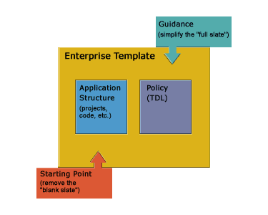
Components of an enterprise template in Visual Studio .NET

Enterprise Templates
Enterprise templates contain two key components: the initial project structure, or template project, and the policy that is associated with the project. The template project is the solution for the blank-slate problem. Using templates, an architect can create an application starting point that includes reusable components, projects and solutions, which developers can use to construct an application. The policy component associated with a template project provides the solution to the full-slate problem. An architect can specify which technologies should be used, as well as which technologies should not be used, so that developers can choose from a narrower list of appropriate options at any given time during the development of an application.

Enterprise Template Projects
Using template projects, architects can establish the blueprints for an application. For example, a simple distributed application might contain a project for each of three architectural layers: user interface, business logic and data. In addition to specifying this initial structure for an application, an application architect can include in the Template Projects’ standard components and any other reusable assets that are appropriate for the application.
Visual Studio .NET includes the Simple Distributed Application and the more complex Distributed Application predefined Template Projects. Both are available with Visual Basic .NET or Visual C# .NET as the default component language. These projects can be used as is or customized and saved as new project types that are available within the New Project dialog box.
To build a new template from scratch, users simply select Enterprise Template from the New Project dialog box. The next step is to add components, classes, projects and other items to the template project. These items create the high-level application structure that can be used as a starting point. The solution can be saved and provided to developers for use as a standard template project, appearing as an option in the New Project dialog box.
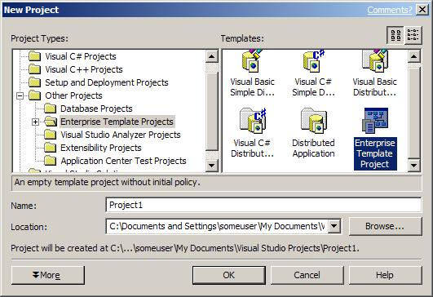

Policy
When a developer uses the template project, its associated policy is automatically applied within the context of the Visual Studio .NET environment. Policy can even be attached to pre-existing projects, with any violations referenced in the task list for easy correction.
Policy is provided using a new XML-based language, Template Description Language (TDL). TDL enables an architect to control the Visual Studio .NET environment, including the task list, toolbox, property browser, solution explorer, designers and editors, and even dynamic help. For example, the following code shows how to use TDL to disable the SQL Connection on the Toolbox.
< TOOLBOXCONSTRAINT >
tboxDataSQLConnection
< ENABLED >0< /ENABLED >
< /TOOLBOXCONSTRAINT >
Using TDL, architects can specify the appropriate technologies for developers to use, set default property values or ranges of values, and even include design documents and other information in dynamic help, so developers can fully understand the architectural vision. Organizations can create as many policy files as they need and can associate them with any enterprise template project.

Enterprise Frameworks
Enterprise frameworks are reusable components built by Microsoft to simplify common programming tasks. These components will be delivered as horizontal and vertical frameworks. Horizontal frameworks can be thought of as technology-focused and pertinent to all applications — for example, components for application management or error handling. Vertical frameworks, on the other hand, apply to specific application domains. An example of a vertical framework is a business-to-consumer (B2C) or business-to-business (B2B) e-commerce application. The initial focus for Visual Studio .NET will be on horizontal framework components.
The first delivered framework component focuses on simplifying application manageability and instrumentation. This framework will dramatically simplify the process of designing applications for manageability by encapsulating multiple lower-level technologies with one easy application programming interface (API) call. Some of the key benefits of this framework are these:
- Simple, unified tracing and event model. A single high-speed API provides access to all functionality.
- Intuitive business-task correlation for events. Events can easily be mapped to corresponding business processes or tasks for more intuitive diagnostics.
- Flexible and configurable runtime settings. Highly configurable settings enable events raised to be modified as needed in production.
- Standards-based implementation. The framework leverages Microsoft Windows Management Instrumentation (WMI) and industry-standard event schemas.
In the future, additional framework components will be provided as they become available so that developers do not need to wait for major Visual Studio .NET product releases to take advantage of new reusable technologies.

Summary
One of the key challenges facing information technology organizations is the ability to capture the knowledge of the most experienced developers and architects and share that across development teams. To do this efficiently and flexibly, with a minimum of intrusion, Visual Studio .NET includes enterprise frameworks and templates — key features for creating application starting points, defining development policy and best practices, and simplifying common development tasks with enterprise framework components. These features enable an organization’s strongest resources to increase application development efficiency, so that companies can adapt quickly to the ever-changing business environment.
Object role modeling (ORM) provides a conceptual, easy-to-understand method of modeling data. The ORM methodology is based on three core principles:

Business Rules Based Design
- Simplicity. Data is modeled in the most elementary form possible.
- Communicability. Database structures are documented using language that can be easily understood by everyone.
Benefit Summary
- Simply describe business rules using easy-to-understand fact statements
- Seamlessly move between conceptual, logical and physical database models
- Clearly communicate business rules across the development team
- Accuracy. A correctly normalized schema is created based on the data model.
Typically, a modeler develops an information model by gathering requirements from people who are familiar with the application but are not skilled data modelers. The modeler must be able to communicate data structures at a conceptual level in terms that the nontechnical business expert can understand. The modeler also must analyze the information in simple units and work with sample populations. ORM is specifically designed to improve this kind of communication.

Rules Expression
ORM represents the application world as a set of objects (entities or values) that play roles (parts in relationships). ORM is sometimes called fact-based modeling because it verbalizes the relevant data as elementary facts. These facts can’t be split into smaller facts without losing information.
Here are some examples:
- A Person has a phone
- A Person lives at an address
- A Person is born on a date
- A Person is hired on a date
The corresponding ORM model for these facts looks like this:
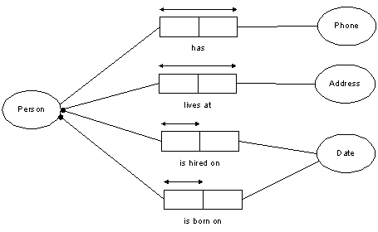
The object role model
The circles in the diagram represent objects; the boxes represent predicates. In ORM, as in logic, a predicate is just a sentence with object holes in it. The arrows and dots represent constraints on the system.
For example, the arrow over the predicate in the “A person has a phone” fact translates to: It is possible that some person has more than one phone and that more than one person has some phone.
In the “A person is born on a date” fact, the combination of the arrow over the predicate and the dot that connects the object to the predicate signifies this: Each person is born on exactly one date.

Contrast to Entity Relationship
Entity relationship (ER) is another type of database modeling. Contrast the simplicity of the ORM model to its ER counterpart:
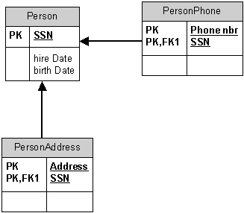
The entity relationship
Where ORM describes business facts in terms of simple objects and predicates, entity relationship methodologies describe the world in terms of entities that have attributes and participate in relationships. In the ORM example in Figure 1, Person, Phone, Address and Date are all represented as objects that play roles relative to each other. In the ER example, Person is an entity that is described by the attributes Address and Phone.
If, for instance, we want to break Address down into Street, City, State and ZIP Code, we have to change Address into an entity type with the corresponding attributes, which also will change the nature of the relationship between Person and Address. Although the constraints expressed in the ORM model above can be expressed in ER, ER requires many other constraints to be expressed by adding notes to the model or writing application code to supplement the model.

Advantages of ORM
ORM provides a simple, direct way of describing relationships between different objects. ORM also provides flexibility, as demonstrated in the above example. Models created using ORM have a greater capacity to adapt to changes in the system than those created using other methodologies. In addition, ORM allows nontechnical business experts to talk about the model in terms of sample populations, so they can validate the model using real-world data. Because ORM allows reuse of objects, the data model automatically maps to a correctly normalized database schema.

The simplicity of the ORM model eases the database querying process. Using an ORM query tool, users can access the desired data without having to understand the underlying structure of the database.

Database Generation and Round Trip Engineering
Like any good modeling method, ORM is more than just a notation. It includes design procedures to help modelers map conceptual and logical models as well as to use reverse engineering to switch between those models.
ORM models also can be automatically mapped to database schemas for implementation on most popular relational databases. In the previous examples, the ORM model can automatically generate the ER diagram, or logical model, which can then be translated into SQL code and applied to the database of choice.

Summary
Leveraging the knowledge of the nontechnical business expert is critical to ensuring that applications meet their business requirements. ORM, a feature in Visual Studio .NET, is an intuitive and easy-to-use conceptual data modeling approach. By using language that is comprehensible by more than just the database expert, ORM enables those who best understand the business requirements for an application to directly impact the design.
ORM also supports full round-trip engineering, so that once the business requirements have been defined they can quickly be converted into logical and physical database diagrams. Using ORM, organizations can take the application development process to a higher level of efficiency and ensure that the business requirements are accurately delivered.
Customers building complex distributed applications face the challenge of successfully communicating application architecture and requirements across a broad range of team members. This challenge compounds when dealing with loosely coupled XML Web services. It is common knowledge that the presentation of concepts and information in multiple formats — visual, spoken and written — enhances people’s ability to understand messages quickly and accurately. Taking this multiple-format approach to communication, Visual Studio .NET helps foster team coordination and productivity by providing a rich set of visual modeling tools for specifying application architecture and requirements.

Visually Modeling Software Architecture
Benefit Summary
- Visually communicate the business requirements for an application
- Clealry specify and communicate the application architecture
- Take advantage of industry-leading diagramming capabilities built on Visio technologies

An Industry-Standard Approach
Visual Studio .NET delivers support for a full range of design and modeling activities, including the free-form diagramming capabilities of Visio as well as a set of industry-standard Unified Modeling Language (UML) diagrams. UML is a notation for visually describing and interpreting the pieces, relationships and actions that make up a software application.
With the Visual Studio .NET modeling features, users can create sophisticated diagrams to specify their application architecture and business requirements as well as communicate these across their teams. Business analysts, architects, developers and others who want to perform analysis and design tasks to enhance communication and increase the productivity of their development teams can take advantage of these new capabilities. The following scenario demonstrates how the structure of a particular software system can be visualized and more effectively communicated by using software models created in Visual Studio .NET.

Application Scenario: A Car Rental Software System
This scenario discusses how the eight UML diagram types might be used to model a car rental agency’s software system. Beginning with three simple use cases, the examples capture the core processes in the system.

Use Case Diagram
A use case specifies an interaction between a user and the system in which the user is able to achieve a goal. A typical software system might include hundreds of simple use cases. Here are some use cases applicable to the rental agency’s system:
- Customer reserves car. Before obtaining a car, a customer must make a reservation. The customer contacts the rental agency and makes a request. The agency accepts or declines the request based on a number of criteria, such as the availability of cars or the customer’s rental history. If the reservation is accepted, the agency completes a form containing customer details. Payment of a deposit completes the reservation.
- Customer picks up car. When the customer arrives at the agency, the rental agency allocates the model of car requested by the customer, depending on current stock levels. After paying the full fee, the customer receives the car.
- Customer returns car. The customer returns the car to the agency on the day specified in the rental agreement.
The following image depicts the use-case diagram for these three use cases.
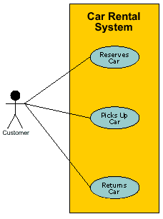

Static Structure (Class) Diagram
The next task is to classify the objects involved and their relationships. Examining use cases helps identify classes. Classes of objects are modeled using static-structure, or class, diagrams that show the overall structure of the system, as well as relational and behavioral properties.
In a class diagram, the objects involved in the car rental system are grouped into classes. Each class contains a name section and an attribute section. Some classes also include an operations section, which specifies how objects within that class may behave.
In the Customer class, attributes include name, telephone number, driver’s license number and address. The date of birth is required to determine that the customer meets the minimum age requirement to rent a vehicle. The Customer class also stores operations such as reservations.
Class diagrams support inheritance. In the following figure, for example, the Mechanic and Rental Agent classes inherit attributes, such as name and address, from the Employee class.
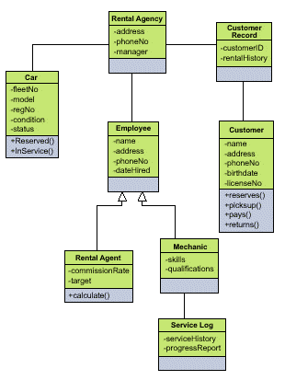

Sequence Diagram
A sequence diagram provides a detailed view of a use case. It shows an interaction arranged in a sequence over time and helps to document the flow of logic within the application. The participants are shown in the context of the messages that pass between them. In a comprehensive software system, the sequence diagram can be quite detailed and can include thousands of messages.
Suppose that a customer wants to reserve a car. The rental agent must first check the customer’s records to ensure that the customer may do so. If customers have rented a car from the company before, their rental history will already be recorded, and the agent need only ensure that all previous transactions ran smoothly. For example, the agent can confirm that a customer’s previous rental cars were returned on time. Once the customer’s rental status is approved, the rental agent can approve the car rental reservation. This process can be represented in a sequence diagram, as shown in the figure below.
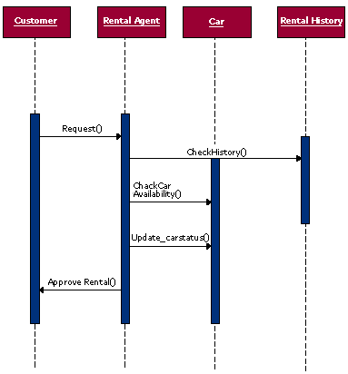

Collaboration Diagram
A collaboration diagram is another type of interaction diagram. Like a sequence diagram, it shows how a group of objects in a use case work with one another. Each message is numbered to document the order in which it occurs.
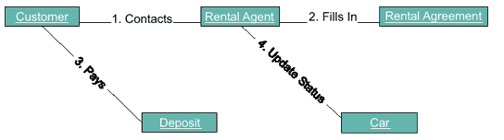

Statechart Diagram
An object’s state is defined by its attributes at a particular moment. Objects move through various states as they are influenced by outside stimuli. The statechart diagram maps these states, as well as the triggering events that cause the object to be in a particular state. For example, in the car rental system, the object is a car. As a car moves through the rental system, its many states produce a complex but illuminating diagram. For example, it is first added to the fleet. It remains in the state InStock until it is rented. After renting, the car is returned to the fleet and to the InStock state. At various times in its commercial life, the car may require repairs (InService). When the car reaches the end of its usefulness, it is either sold or scrapped to make way for a new vehicle.
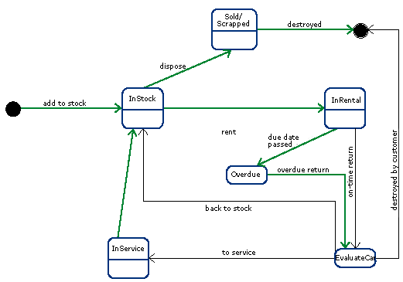

Activity Diagram
An activity diagram displays the logic that occurs in response to internally generated actions. An activity diagram relates to a specific class or use case and shows the steps involved in carrying out a particular operation.
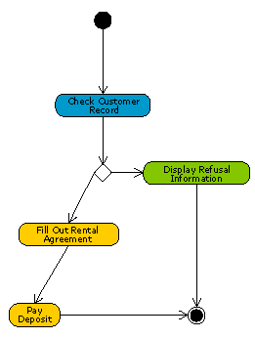

Component Diagram
A component diagram shows how various software subsystems make up the overall structure of the system, which is built on a centralized database that contains past rental records, car details, service records, and customer and employee details. It is critical that this data be centralized in one database because stock levels vary by the hour and all parties must have up-to-the minute information. Keeping the data current requires real-time information updates by all parties. The software subsystems for this example include Car Records, Service Records, Sales Records, Customer Records and Employee Records.
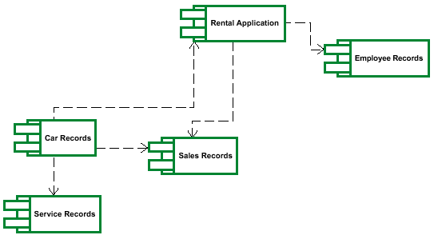

Deployment Diagram
A deployment diagram shows how the hardware and software in the system are configured. The rental agency needs a client/server system with a central database of records that the staff can access. Rental agents need access to the data on vehicle availability. Meanwhile, mechanics need to be able to flag a particular car as being in the InService state.
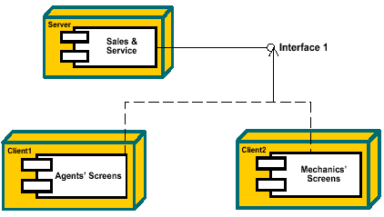

Free-Form Modeling
Many customers also want the ability to add other graphical elements to the UML diagrams in their application models. Because Visual Studio .NET includes Microsoft Visio drawing and diagramming software-based modeling tools, it enables free-form modeling, such as flow charts and other nonsemantic diagrams, as well as the ability to embed any image within a model. This provides customers with additional flexibility in communicating their application architecture and functionality. The tight integration of Visio with other Microsoft Office applications makes it easy to share models and diagrams with others.

Summary
During the application life cycle, many people of varying technical backgrounds need to interact and communicate to successfully accomplish the common goal of creating a new application. Visual Studio .NET provides key features — industry standard software modeling and rich free-form diagramming capabilities — for specifying and communicating architecture. Customers who use these features will benefit through more effective communication within their development teams, which will increase the efficiency of developers and the success rate of software projects in their organizations.
With the rise of loosely coupled computing and XML Web services, organizations require tools that enable them to deliver successful solutions that scale to meet the demands of a global user base. Visual Studio .NET not only provides the industry-leading tools for constructing XML Web services and applications, but it also includes critical features for testing the scalability, performance and functional integrity of these applications.

Performance, Load and Functional Testing of XML Web Services
Application Center Test (ACT), a new feature integrated with Visual Studio .NET, enables developers to gather performance metrics and perform functional testing of XML Web services and applications within the Visual Studio .NET development environment.
Benefit Summary
- Quickly create powerful scalability and performance tests for XML Web services and applications
- Take advantage of flexible functional testing capabilites for XML Web services and applications
- Visually compare multiple test-run results to identify problem areas
- Automate tests for easy and consistent regression testing
ACT provides sophisticated scripting capabilities, so developers can analyze relative performance by simulating many simultaneous page requests to an XML Web service or application. This helps developers design faster, more stable XML Web services and applications.
This section discusses the primary types of tests that can be created and their attributes. Topics will include how to do the following:
- Directly enter test scenarios
- Record test scenarios easily using a browser
- Extend test scenarios through scripting
- Configure and save test scenarios for later reuse or regression runs
The section will then focus on running the tests to generate application load, capturing results in log files, using customizable reports and views to analyze performance, and automating the testing process.

Creating Tests
ACT provides two types of tests: static and dynamic. Static tests use a grid interface similar to Microsoft Excel that does not require programming to create. These tests are produced using the main ACT user interface. Dynamic tests, on the other hand, utilize an object model that is specifically designed for creating stress tests and that can be edited directly from the Visual Studio .NET IDE. These tests can be created using Microsoft Visual Basic Scripting Edition (VBScript), Microsoft JScript .NET development software or Perl.
Developers can create each type of test by using a couple of different methods. Each method is described below.

Browser Record Test
The Browser Record test-creation method is invoked from the main ACT user interface. When developers create a browser record test, ACT captures all of the HTTP requests sent by their browser as they navigate a Web application. This makes it easy to create an accurate test because it captures all the inline images that would otherwise be automatically requested by the browser. Developers have the option of creating either a static or a dynamic browser record test.

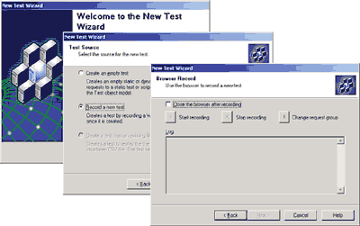
Creating a Browser Record test
If a dynamic test is chosen, the Visual Studio .NET IDE can be used to edit and run the test, making it easy to code the application while obtaining functional and performance information within the same environment.

Importing a Web Server Log File
If a Web server log is available (for example, if a log has been created from the live production site), it can be imported into the tool to create a test that accurately simulates real-world Web traffic. Web server log files are imported using the main ACT user interface.
Web server log files import the following formats:
- Microsoft Internet Information Services (IIS) log file format
- NCSA Common log file format
- W3C Extended log file format

Change a Static Test into a Dynamic Test
If developers create a static test by using one of the above test-creation methods, they can easily convert it into a dynamic test. Dynamic tests provide greater flexibility because they allow the script to analyze the response from the Web server and take conditional action.

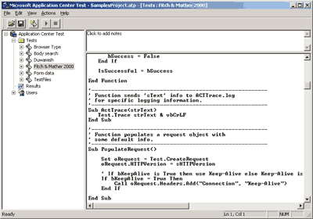
A dynamic test

Configuring Tests
Developers can use the test properties to set the number of simultaneous requests that are generated and the uniqueness of each request. If developers are using the main ACT user interface, they need to right-click a test to view the properties associated with it. If they are using the Visual Studio .NET IDE, they can view properties for the selected test in the Project properties view.
Each test type allows the developer to specify either the exact number of simultaneous browser connections or a target number of requests per second that the tool automatically achieves. Tests are run for either a number of iterations or a length of time.
The property pages for a test also control whether the tool automatically creates unique users or cycles through a predefined list of user names and passwords. This option is useful for Web sites that require specific user names to be authenticated.

Running Tests
Once the test is created and configured, developers must right-click the test name and select Run Test to execute a test run. While the test runs, the tool displays run-time data that provides a visual status of the request rate and feedback on any errors that may occur during the stress test.
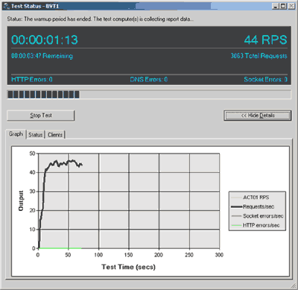
View test results while running

Analyzing the Results
Understanding the results of performance tests is critical to the successful tuning of an XML Web service or application. ACT provides a rich set of standard reports that are built using XML and that can be easily customized by developers to depict the information pertinent to their applications.
The default information that is available while running tests in the Visual Studio .NET IDE includes the following:
- Requests per second
- Time to first byte (response-time metric)
- Time to last byte (response-time metric)
- TCP and HTTP errors
- Number of satisfied requests
The main ACT interface contains more detailed information regarding the results of a test. The Results section contains several predefined charts that display the most commonly requested performance metrics.
Developers also can use the custom chart option to create a chart that contains metrics from several different tests as well as any number of runs that have occurred from within all tests. In addition, the results contain tabular data that displays the relative performance of all the pages that were tested, as well as general test information and settings.

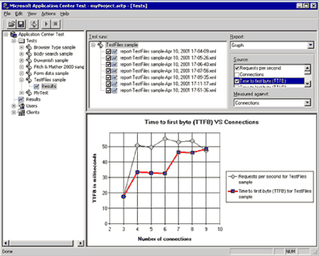
Using the Custom Chart option

Automating Tests
ACT enables developers to automate the test process by using the application object model that controls the ACT test tool itself. The application model is accessible from Microsoft Visual Basic for Applications (VBA), other scripting languages that understand COM, and any of the Visual Studio .NET languages. This allows developers to create powerful sets of tests that can be run automatically, and dramatically simplifies the process of running regression tests and other routine tasks.

Summary
Visual Studio .NET provides industry-leading tools for building XML Web services and applications. A critical factor for customer success in building and deploying these applications is to ensure that performance scales to support a global user audience. In addition, customers need to verify the functional correctness of their XML Web services and applications to meet their business requirements. To address these issues, Application Center Test includes features for performing stress, load and functional testing of XML Web services and applications — all integrated into the IDE. This provides a cost effective way for organizations to incorporate testing early in a project and to perform testing as part of their overall application life cycle. Tests generated by developers can be easily reused by testing and operations groups and automated for maximum efficiency and coverage. All of this results in a more predictable and supportable application development process.
Deployment (the process of distributing and installing an application) presents a challenge for both the developers of an application and the network administrators that must install and maintain it. The developer often has to make assumptions about where and how the components of distributed applications will be installed; the administrator must deal with issues ranging from version conflicts to dependencies.

Deployment in Visual Studio .NET
Visual Studio .NET meets the challenge by offering new tools for deployment, simplifying the process for both the developer and the administrator. The aim of Visual Studio deployment is to transport solutions of any size or makeup from a development platform to multiple target platforms in a single step. The following are just a few of the features of deployment in Visual Studio .NET:
Benefit Summary
- Easily deploy distributed applications
- Simplify setup of server-based resources including databases and message queues
- Reduce DLL conflicts with side-by-side components
- Deployment is fully integrated as a part of every solution, not an add-on.
- Users can deploy to Web servers such as Internet Information Server, non-Web servers, traditional media such as CDs or any combination of the three — all in a single step.
- Solutions for debugging can be deployed across multiple machines.
- The .NET Framework including installer classes is fully supported.
- The Zero Administration initiative for Windows, including side-by-side installation and application publishing, is supported.

Deployment Solutions
In the past, deployment was usually an afterthought — only after coding and testing an application did developers think about deployment. This way of working, however, often caused problems such as version conflicts and missing dependencies. Deployment was accomplished using add-on tools that had no first-hand knowledge of the application, instead relying on developers to fill in the details.
In Visual Studio .NET, deployment is a fully integrated part of every solution. Within a solution, deployment projects are used to store information about where and how each piece of the application will be deployed. Typically a developer will create a separate deployment project for each level of a multitiered application. Each deployment project is associated with one or more projects in the solution by adding the project’s outputs and content files.
As changes are made to a project during the application’s life cycle, the deployment project associated with that project automatically picks up the changes, ensuring that the latest version will always be deployed.
For example, a developer is creating a three-tier Web application. The solution contains a main Visual Basic .NET Web project plus a Visual C# .NET project that implements a control used in the Visual Basic project. Additional projects implement the middle and back-end tiers of the application. In this case, the solution would include three deployment projects: one for the Visual Basic project plus the control and one each for the middle and back-end tiers.
The developer uses the deployment editors to configure deployment characteristics for each project, specifying where files are to be installed on the target machine, what registry keys to set, what conditions must exist on the target machine, what user interface to display during installation and other details.
Later, he decides he needs another control on an HTML page in the Visual Basic .NET project, so he adds a new Visual C# .NET project to the solution, creates the control and adds it to the page. Because the control is a dependency of the Visual Basic project, the deployment project is automatically aware of the change. The next time the solution is deployed, the new control is deployed as well — with no extra effort from the developer.

Types of Deployment
Deployment involves much more than creating setup applications. In addition to distributing applications using traditional media such as CDs, it has become common to deploy applications across a corporate network or even via the Internet.
Visual Studio .NET allows developers to deploy via any of the above methods. Three basic deployment types are supported: setup projects (deploy to a file system), Web setup projects (deploy to a Web server) and CAB file projects (deploy via Web download). With any of these types, developers can choose to deploy via CD or other traditional media, deploy to a network server for later installation, or deploy and run automatically in a single step.
In addition, developers can choose merge module projects to package components for reuse. Merge modules can be shared between multiple deployment projects; they are like a “snapshot” of a specific version of a component. By using merge modules for all components, developers can eliminate version conflicts and distribute only what is necessary.
Developers will often mix and match the different deployment methods within a single solution or change the method of deployment during the life cycle of the application.
Here’s another example. A developer creates a Web application for her company. Her solution consists of a Web project, a project for a component used by the Web project and a standalone database. In this case, she will use three deployment projects in her solution.
She adds a Web setup project for the Web project, setting it to deploy to her company’s Web server. Next, she adds a merge module to package the component, adding the output of the merge module project to the Web setup project. She adds a setup project for the database, setting it to deploy across the network to a server.
Her application is hugely successful, so she decides to market it to other companies as a packaged solution. By simply changing the deployment projects to deploy to a CD, she can now sell her application and her customers can install it on their own Web servers and have a ready-to-run application.

Deploy for Debugging on a Remote Machine
One of the most valuable features of Visual Studio .NET is the ability to debug code running on another machine. People who have developed distributed applications have undoubtedly run into a situation where server code runs correctly on their development machine but breaks once deployed to a production server. Debugging this type of problem can be a frustrating and time-consuming proposition.
The deployment mechanism in Visual Studio .NET overcomes this problem by enabling developers to deploy the code to the server from within the development environment. This allows developers to debug the code in its intended environment, making it much easier to discover problems that may be machine-specific.
For example, consider a Web application that containing code that runs on the Web server when users click a button on a Web page. The developer adds a deployment project for the Web application and chooses an option to deploy automatically when the F5 run command is invoked.
The developer sets a breakpoint in the server code and runs the application. When he clicks the button on the Web page the server code is invoked, stopping at the breakpoint. He steps through the code a line at a time and inspects values to find the problem. Once he has fixed the code, he runs the application again and the revised code is deployed to the server, allowing him to test his fix.

Microsoft .NET Framework Installer Classes
Many of the server-related features of Visual Studio .NET present a unique challenge when it comes to deployment. For example, it’s easy to use the Microsoft Message Queue component in an application, but that component requires that a specific message queue is installed and configured on a target server.
The .NET Framework allows installation information to be included in an installer class so that a server component can install and configure itself automatically. Installer classes are built into the assembly for that component.
Visual Studio .NET deployment allows developers to add the installer class to a deployment project as a custom action — an action that is run automatically at the end of an installation. The server component will be installed and configured, and the developer doesn’t have to worry about writing configuration scripts.
Support also is provided for other types of custom actions that can be run at the end of installation. The developer can create executables or scripts to handle any special situations that aren’t covered by standard deployment methods.

Windows 2000 Support
Windows 2000 greatly eased the task of installation with zero-administration features such as application publishing. Windows Installer technology made this possible.
Visual Studio .NET deployment is built on top of the Windows Installer technology. Windows Installer differs from traditional setup technologies in that it is component-based as opposed to having a set of sequential steps. In the past, a setup program was script-based; setup steps had to be executed in order, and if a step failed, there was no way to roll back the installation. Windows Installer-based setups store installation information in tables, allowing precise control over an installation and providing complete rollback capabilities.
The inclusion of Windows Installer technology in Visual Studio .NET allows developers to create installers that support Windows 2000 features such as publishing capabilities.
Publishing or advertising is a means of providing Windows 2000 with information about applications without actually installing anything on users’ machines. When they want to install the application, Windows 2000 uses this information to find the application on the network and install it. Published applications show up in the Add/Remove programs group on machines running Windows 2000.
Summary

Simplify Development of XML Web Services and Applications
As the Internet continues to evolve into a fully programmable environment for conducting business, XML Web services become a fundamental component for integrating applications and accessing services exposed by other organizations. Visual Studio .NET simplifies the development and invocation of XML Web services by supporting XML throughout the entire tool set. By automating the task of creating complex XML data structures, developers using any language can quickly and effectively expose components as XML Web services. And because XML Web services are built and accessed using standards-based XML and the Simple Object Access Protocol (SOAP), Visual Studio .NET developers can integrate external XML Web services running on any platform into their applications.
In addition, the Visual Studio .NET unified development model enables developers to leverage their existing skills to create advanced Web applications. In Visual Studio .NET, familiar WYSIWYG designers are provided for creating Web Forms and server-side components.

Maximize Developer Productivity
Visual Studio .NET provides an extensive set of new productivity tools and enhancements to simplify the design, development, debugging and deployment of next-generation distributed applications. From the enhanced, unified IDE to the rich extensibility model and support for macro recording, Visual Studio .NET delivers a complete and flexible environment for creating enterprise-critical applications. In addition, new tools such as the Server Explorer, Task List and integrated end-to-end debugger empower developers to quickly and easily manage complex, N-tier applications. Finally, the fully customizable Visual Studio .NET Start Page and Dynamic Help provide developers with the information and resources they need to succeed in their development tasks.

Innovate in Languages
Most professional development projects consist of components and code developed in multiple languages. Visual Studio .NET supports solutions created using multiple languages and enables developers to seamlessly inherit and debug these cross-language applications.
In addition, Visual Studio .NET provides developers with a choice of world-class languages to suit their development experience. In Visual Basic .NET, developers are empowered with an enhanced Visual Basic language that fully supports object-oriented constructs and direct access to the .NET Framework. Developers using Visual C++ can take advantage of the power and performance of attributed programming and integrate existing applications with the .NET Framework using Managed Extensions for C++. C and C++ developers seeking to maximize productivity will benefit from Visual C# .NET, Microsoft’s newest, component-oriented language. Finally, JScript .NET brings full object orientation to the widely used Web scripting language.

Enterprise Life-Cycle Support
Visual Studio .NET will expand the capabilities of software architects and developers by enabling greater sharing of development knowledge and expertise. Visual Studio .NET Enterprise Architect and Visual Studio .NET Enterprise Developer provide software and database modeling tools for visually communicating application architecture and requirements, enterprise frameworks and templates for giving developers a starting point and architectural guidance, and a set of test tools for ensuring that XML Web services and applications are scalable to meet business requirements. Visual Studio .NET with the Open Tools Platform provides complete enterprise life-cycle productivity, enabling teams to seamlessly incorporate a broad range of rich third-party developer solutions to meet their unique development requirements.
Visual Studio .NET Feature Summary

Visual Studio .NET — Features at a Glance
Developer Productivity

Integrated Development Environment (IDE)
Shared IDE | Single, unified, fully customizable environment shared across all Visual Studio .NET languages
Visual Studio Start Page | Central location for setting preferences, reading product news, accessing developer-related discussions and opening recently accessed projects
Dynamic Help | Provides instant access to help that is relevant to the current development task
Task List | Allows developers to organize the development process by annotating code, monitoring and quickly accessing errors and warnings
Web Forms Designer | Shared graphical way to develop HTML, ASP and ASP.NET Web Forms without delving into HMTL or script
Windows Forms Designer | Drag-and-drop creation of Window-based applications
Server Explorer | Allows developers to access and integrate server administration tools, event logs, databases and XML Web services
Component Designer | Allows rapid visual creation of middle-tier objects
Visual Studio Macros | Allows developers to customize, automate and extend the functionality of the IDE, as well as integrate Visual Studio .NET with other tools such as Office
XML Designer | Provides intuitive tools for working with XML and XSD files
Integrated Debugger | Helps shorten the development cycle with cross-language, cross-process and remote debugging
Solution Explorer | Hierarchical access to multilanguage projects
Command Window | Command-line interface to IDE commands
Auto-Hide Windows | Developers can maximize their workspace area with auto-hide tool windows
IntelliSense | Statement completion and syntax notification for HTML and XML tags
Toolbox | New components for Web Form, Windows Form and Data development that allows developers to store code blocks for reuse at a later time
Solution/Project/Item Build and Build Configurations | Build functionality and UI, including build configurations
Multimonitor support | Provides the ability to open more windows at once without sacrificing screen space
Environment SDK | Allows developers to extend the IDE to their preferences
Server Explorer | This new, developer-centric window helps access server-based resources.
Component Designer | RAD for the Server enables drag-and-drop programming for nonvisual objects.
Powerful Server Components | Integrated server components help simplify building applications that use Exchange, MSMQ, Performance Counters and Events Logs.
Dynamic Properties | Developers can modify application functionality without writing or compiling new code.

XML Web Services
Easily expose any component as an XML Web service | Developers can use the keyword <Webmethod()> to automatically expose any function or method as a XML Web service.
Consume XML Web services from any platform | Developers can work against XML Web services regardless of the operating system or hardware platform that they are implemented on and take advantage of key Visual Studio productivity features including IntelliSense statement completion.

Web Forms
Web Forms Designer | Developers can rapidly build broad-reach Web applications using the familiar forms-based approach. By dragging and dropping Web controls, developers can visually lay out a Web page and then implement business logic in a compiled language such as Visual Basic or the Visual C# development system.
Web Controls | Developers can rapidly build scalable Web applications that can service multiple-user interface devices. Web Controls are compiled and run on the server for maximum performance and can be inherited and extended for even more functionality.

Programming the Mobile Internet
Mobile Web Forms Controls | These controls generate markup language for different devices.
Mobile Internet Designer | This integrated Visual Studio .NET designer provides drag-and-drop mobile development.

Windows Forms
Form Inheritance | Developers can increase productivity by sharing standard forms that can be inherited and extended across an organization.
Menu Designer | Developers can quickly define Windows Menus and see how they look without having to run an application.
Windows Forms Designer | This feature allows drag-and-drop creation of Window-based applications.
Powerful Graphics Control | Fine-grained control of graphics features enables powerful, professional looking applications.
Control Anchoring and Docking | These features provide flexible and powerful layout for controls.
Powerful Languages

Visual Basic .NET
Object-Oriented Features | Code reuse is enhanced with full object-oriented programming features including Inheritance, encapsulation, overloading and polymorphism.
Implementation Inheritance | The Inherits keyword enables rapid application assembly and maximum code reuse by deriving from existing classes.
Direct Access to .NET Framework | Developers can directly access the comprehensive programming interface to .NET.
Overloading | The Overloads keyword allows developers to create different versions of a Sub or Function with the same name but different argument types.
Seamless Language Interoperability | Developers can easily inherit code and forms from other .NET languages, interact seamlessly with other languages and debug multilanguage applications.
New Project Types | Users can easily create Windows console, XML Web service, Windows Service and Web projects.
Parameterized Constructors | Developers have the ability to create a new instance of a class while simultaneously passing arguments to the new instance.
Free Threading | The new Thread class enables highly scalable asynchronous applications.
Structured Exception Handling | Try…Catch…Finally helps minimize code duplication for error handling.
Strict Type Checking | Improved type safety helps reduce run-time errors.
Multimodule Files | Developers can place multiple modules and classes into a single .vb source file.
Shared Members | Users can share a single instance of a class data member or method among all instances of the class.
Namespace Aliasing | Developers can create intuitive aliased, hierarchical namespaces.
Initializers | Developers can initialize variables on the line on which they are declared.
Upgrade Tool | Existing Visual Basic 6.0 projects can be upgraded to Visual Basic .NET.
Delegates | Powerful function pointers can reference and call static and instance methods.
Reflection | Custom attributes defined directly on a member can be returned.

Visual C++ .NET
Attributes | Attributed COM+ programming reduces the amount of code to be written.
Managed Extensions | Managed Extensions for C++ help developers using Visual C++ write applications for .NET.
ATL Server | ATL Server enables high-performance XML Web services to be written using C++.
Error Detection | Developers can write stable code using features that automatically detect buffer overruns.
Optimizing Compiler | Developers can write powerful, high-performance applications with the optimizing compiler.
Enhanced MFC and ATL | Existing applications can be updated with new Windows features in MFC and enhanced ATL classes.

Visual C# .NET
Versioning | Built-in features support object versioning.
Attributes | Attribute-based programming increases developer productivity.
Garbage Collection | Garbage collection relieves programmers of the burden of manual memory management.
C and C++ Heritage | C and C++ developers can take advantage of this new, modern, productive language.

Creating Application Construction Kits
Enterprise Lifecycle
Enterprise Templates | This new project type and XML-based language helps create application construction kits, providing architectural guidance and sharing best practices across development teams.
Enterprise Frameworks | Reusable components help simplifying complex tasks in distributed applications. These initially include a simplified manageability and instrumentation application programming interface — one simple API call to include powerful management features in an application.
Reference Applications | Fully built-out applications include design documents and implementation reasons showcasing best practices from Microsoft experts.

Industry-Leading Database Tools
Conceptual Database Modeling | Capture business rules using simple fact statements to clearly communicate requirements across the development team through seamless integration with logical models and physical database schema in SQL Server, Access, Oracle and DB2
Logical and Physical Database Modeling | Industry-standard logical models, including ER and IDEF1X
Visual Database Tools | Work with stored procedures, indexes, tables, triggers, user-defined functions and other database elements
Powerful Software Modeling Built on Microsoft Visio Technologies

Visually Modeling Software Architecture
Full UML 1.2 Modeling | Take advantage of any UML 1.2 diagram, including Use Case, Activity, State, Component, Class and Deployment, to specify the application architecture and communicate functionality.
Semantic Error Checking | Robust and flexible error checking will validate models against the UML specification
Visio Standard Diagramming | Easy-to-use diagramming and charting capabilities built on Visio can be used to more clearly communicate application functionality.
Business Process Modeling | Capture business process flows and corresponding implementation with the BizTalk™ Orchestration features

Performance, Load and Functional Testing of XML Web Services
Performance and Scalability Testing | Developers can quickly and easily create scripts to exercise an XML Web service or application to verify performance and scalability.
Functional Testing | Powerful and flexible scripting enables functional testing of XML Web services and applications.
Automated Testing Capabilities | Developers can automate tests to increase productivity and easily run regression passes on an application.
Deployment

Deployment
Multitier Setup Projects | Developers can deploy to all tiers of an application.
.NET Installer Classes | Installation of databases and message queues is simplified.
Windows 2000 Support | DLL conflicts are eliminated with side-by-side components.

Visual Studio .NET Features by Edition
Feature | Professional | Enterprise  Developer | Enterprise  Architect
Visual Studio .NET development environment | • | • | •
Create and use XML Web services | • | • | •
Complete Web development environment | • | • | •
Build powerful Windows applications | • | • | •
Target handheld devices | • | • | •
Industry-leading languages:  - Visual Basic .NET  - Visual C++ .NET  - Visual C# .NET | • | • | •
Developer editions of:  - Windows 2000 Server  - SQL Server 2000  - Commerce Server 2000  - Host Integration Server 2000  - Exchange 2000 Server |  | • | •
Visual SourceSafe |  | • | •
XML Web services and applications testing |  | • | •
Visual database tools |  | • | •
.NET reference applications |  | • | •
Enterprise frameworks and templates execution |  | • | •
Enterprise frameworks and templates authoring |  |  | •
BizTalk Server Developer Edition |  |  | •
Software modeling |  |  | •
Logical database modeling |  |  | •
Conceptual database modeling |  |  | •

How can I get the Microsoft Visual Studio .NET beta release?

Frequently Asked Questions
There are several ways to obtain the Visual Studio .NET beta release:
- Download from the Web
  - Current MSDN Universal subscribers can download the beta 2 release at http://msdn.microsoft.com/subscriptions/resources/subdwnld.asp.
  - Non-subscribers can sign up at http://msdnbuynow.one.microsoft
.com/MSDN_Entry.asp.
- Order Visual Studio .NET beta 2 on DVD or CD
  - Customers in the United States or Canada can order at http://developerstore.com/devstore/product.asp?productID=7590&store=TOOLBOX_NA.
  - Worldwide customers can order at http://developerstore.com/devstore
/product.asp?productID=7590&store=Toolbox_INTL.
- Wait for a beta 2 DVD included with several developer magazines in September 2001.
  - In September, a number of developer magazines will include the beta 2 DVD as part of a joint promotion with Microsoft.
What are the system requirements for Visual Studio .NET beta 2? (Hardware and Software)
The Visual Studio .NET beta 2 has been tested on the Microsoft Windows 2000 Server, Windows 2000 Professional, Microsoft Windows NT Server and Windows NT Workstation version 4.0. Web application development and some server-side components require Windows 2000. The hardware requirements for the beta 2 release may be higher and its performance may be lower than the final Visual Studio .NET release. We recommend the following hardware configuration for
beta 2:

Beta 2 Minimum Requirements | Beta 2 Recommended Requirements
Pentium II 450MHz or compatible processor | Pentium III 600MHz or compatible processor
Windows 2000 Professional: 96 MB of RAM; Windows2000 Server: 192 MB of RAM | Windows 2000 Professional: 128 MB of RAM; Windows2000 Server: 256 MB of RAM
Video card capable of 800x600 screen resolution, 256 colors | Video card configured to 1,024x768 screen resolution, high color
Available hard disk space: 500 MB on system drive, 2.5 GB installation drive | Available hard disk space: 500 MB on system drive, 2.5 GB installation drive
CD-ROM or DVD drive | CD-ROM or DVD drive

What are the differences between the beta 2 CD and the beta 2 DVD?
The key difference is that the DVD contains extensive learning and readiness materials for developers, including code samples, demos, technical articles, white papers, sample book chapters and third-party resources.
If I don’t have a DVD player, can I still receive the learning and readiness materials?
Much of the material on the DVD will be made available in the coming months on MSDN.
Are the recently announced Visual Studio .NET Enterprise Architect or Enterprise Developer beta releases available?
Mainly because they take up a number of CDs, these products are in a more limited beta release and are not available in the United States.
Can I distribute code that I build with Visual Studio .NET?
The End-User License Agreement (EULA) specifically states that users cannot create shipping applications with the beta release. However, a supplemental license for customers who want to deploy server-based applications prior to the final Visual Studio release is available. There are three specific limitations with this license. First, only server-based applications are permitted, for example, ASP.NET applications with browser-based clients. Second, Microsoft is not providing technical support for these applications. Third, users agree to upgrade to the final product within 30 days of availability.
Should I start building production applications with Visual Studio .NET beta 2?
We do not recommend using nonreleased software for production systems.
Is there any support for this beta release?
The beta documentation will describe how to get support — primarily via newsgroups.
Will there be separate betas for the Visual Basic .NET, Visual C++ .NET and Visual C++ .NET development systems?
There won’t be separate beta programs for those tools. Because there are so many shared features among the tools in the Visual Studio development system, it makes sense to have a single beta program.
Where is Visual InterDev?
The Microsoft Visual InterDev® Web development system is included in the Visual Studio .NET Integrated IDE. All languages will have access to the Web development capabilities that were unique to Visual InterDev in the 6.0 product line.

Are you almost ready to ship?
Microsoft has announced that it is planning to release Visual Studio .NET in the second half of 2001.
When is RTM? Will I receive it?
Firm dates have not been set for the release of Visual Studio .NET. Beta 2 users will not automatically receive Visual Studio .NET. Please check back at http://msdn.microsoft.com/vstudio/ for more information on how to purchase Visual Studio .NET when it is available.
Can my Visual Basic 6.0-based applications be upgraded to Visual Basic .NET?
Yes. To take full advantage of the new language constructs in Visual Basic .NET, an Upgrade Tool is included that automatically upgrades Visual Basic 6.0 projects when they are opened in Visual Basic .NET. The Upgrade Tool will modify the language for syntax changes and will convert Visual Basic 6.0 forms to Windows Forms. In addition, the Upgrade Tool generates a report that alerts developers to manual changes that need to be made in their code. Comments are displayed as TO DO tasks in the new Task List window, and developers can navigate to the code statement simply by double-clicking a task item.
How does Visual C++ support Microsoft .NET?
Visual C++ can produce code for the .NET platform. In addition, Microsoft has extensively improved ATL, Microsoft Foundation Classes (MFC) and the compiler. In addition, Microsoft has introduced ATL Server for producing native-code XML Web service applications.
Where can I learn more about Visual Studio .NET and how to build applications with it?
You can get more information from http://msdn.microsoft.com/vstudio/. In addition, the MSDN developer program will carry a number of articles and white papers on Microsoft .NET. Finally, there are newsgroups at http://msnews.microsoft.com/.
Does the beta release work on Microsoft Windows 95, Windows 98 and Windows Millennium Edition?
These platforms will not be supported at design time. This decision was made to ensure that developers could benefit from the most advanced platform features available in the Visual Studio environment. For code execution, Windows 98 and higher will be supported.
How does .NET support my existing COM- and COM+-based components?
The .NET Framework enables developers to call existing COM and COM+ components and enables .NET components to be exposed to COM and COM+ developers. In addition, a considerable amount of COM+ 1.0 “plumbing” has been simplified in the .NET Framework.
Will there be a cross-platform version of the runtime?
There are currently no plans to take the full .NET Framework to non-Windows platforms. However, there is a version of the .NET Framework called the .NET Compact Framework that enables the fundamental architecture of the .NET Framework on small devices such as mobile phones and digital televisions. The .NET Compact Framework is programming-language-, hardware- and operating-system-independent.
Are all of the features completed in this beta release?
Yes, Visual Studio .NET beta 2 is feature complete.
Will code that I write with this beta release work with the final release?
There is a possibility that code written with the beta 2 release will need to be modified to run with the final product.
Will I be able to upgrade my Visual Studio .NET beta 2 installation to the final release, or will I have to reinstall?
You should plan to reinstall the final release. Upgrading may or may not be supported.
Is Visual FoxPro part of Visual Studio .NET?
The Visual FoxPro® 7.0 database development system will not be included in Visual Studio .NET. Because Visual FoxPro 7.0 is not a Microsoft .NET language and does not share the Visual Studio .NET IDE, Microsoft has decided to ship it ahead of and separately from Visual Studio .NET. This will enable developers using Visual FoxPro to benefit sooner from the new features of the product and enjoy the productivity enhancements that it provides.
Visual FoxPro does not take advantage of the common language runtime; however, developers can build Visual FoxPro-based COM components and XML Web services that can be used in applications built with Visual Studio .NET. Components and XML Web services built with Visual Studio .NET can also be used in Visual FoxPro-based applications.
What is the .NET Framework?
The .NET Framework is a platform for building the next generation of distributed XML Web services and applications. It exposes a language-independent yet consistent programming model across all tiers of an application, while providing seamless interoperability with and easy migration from existing technologies. The .NET Framework consists of three things: the common language runtime, unified classes and ASP.NET.
How do I secure my XML Web services?
Because XML Web services look and act like Web pages (using HTTP requests and responding with text that happens to be well-formed XML), they are protected in much the same way that Web sites are protected — through standard Web server authentication mechanisms and the use of HTTPS and SSL to protect the data on the network (or IPSec and firewalls to further restrict access to client machines of known IP addresses).
What is managed code?
Managed code is written to target the services of the common language runtime. To target these services, the code must provide a minimum level of information (metadata) to the runtime. All C#, Visual Basic .NET and JScript .NET code is managed by default. Visual C++ code is not managed by default, but the compiler can produce managed code by specifying a command-line switch (/com+).
Closely related to managed code is managed data, or data that is allocated and deallocated by the .NET runtime’s garbage collector. C#, Visual Basic .NET and JScript .NET data is managed by default. C# data can, however, be marked as unmanaged through the use of special keywords. Visual C++ data is unmanaged by default (even when using the /com+ switch), but when using Managed Extensions for C++, a class can be marked as managed using the “__gc” keyword. As the name suggests, this means that the memory for instances of the class is managed by the garbage collector. In addition, the class becomes a full participating member of the .NET community with the benefits and restrictions that brings. An example of a benefit is proper interoperability with classes written in other languages — for example, a managed C++ class can inherit from a Visual Basic class. An example of a restriction is that a managed class can only inherit from one base class.
Do I have to use garbage collection?
No, but bypassing garbage collection has an impact on interoperability among .NET Framework classes, particularly cross-language interoperability, and is, therefore, not recommended. Depending on the language you use, there are various ways to avoid garbage collection. For example, C# developers can bypass garbage collection via special keywords, and C++ developers must actually choose to use it by marking their class with the “__gc” keyword.
Will I be able to have transacted components in the .NET Framework?
Transactions are fully supported in .NET Framework applications, via tight integration with COM+ Services. COM+ Services includes services such as transactions, object pooling and just-in-time activation. The .NET Framework has made it easier to build applications that use COM+ Services by innovating the programming model and by providing a factored API set for these services that is common across all languages. All the COM+ 1.0 Services can be used in the .NET Framework application.
To increase the productivity of developers and make the .NET Framework as scalable and reliable possible, Microsoft has simplified the programming framework and automated a considerable amount of COM+ Services “plumbing,” so it does look different. Microsoft has provided a bidirectional interoperability mechanism in the .NET Framework so that existing code and new code can work together seamlessly.
Can I use the Win32® API from a .NET Framework program?
Yes. Using P/Invoke, .NET Framework-based applications can access native code libraries via static DLL entry points.



For more information:
The latest information on Visual Studio can be found on the Microsoft Web site at http://msdn.microsoft.com/vstudio/.
The latest information on the .NET framework can be found at http://msdn.microsoft.com/net/.

